**Applied Maths Higher Level 2023**

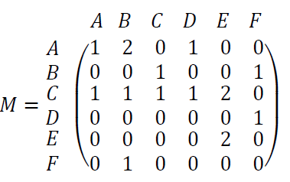

**2023 HL Question 1 (a)**

A directed graph is represented by the adjacency matrix 𝑀, where

1. 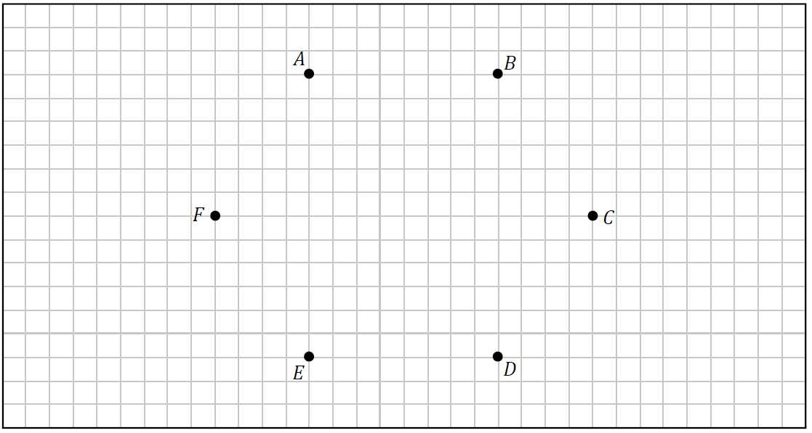Use the nodes below to draw a graph represented by 𝑀.
2. Write down a cycle which starts at node 𝐵.
3. How does a directed graph differ from an undirected graph?

**2023 HL 2023 Question 1 (b)**

A particle moving along a straight line has velocity $v=\frac{ds}{dt}=2te^{-t}$, $t≥0$.

1. Using integration by parts or otherwise, derive an expression for 𝑠(𝑡), the displacement of the particle at any time 𝑡, given that 𝑠(0) = 0.
2. Calculate 𝑠(3).

**2023 HL Question 2 (a)**

A university has decided to improve the paths on its campus. In the network shown below the nodes labelled with the letters 𝑋 and 𝑌 represent the two entrances to the campus and the nodes labelled with the letters 𝐴 to 𝑁 represent the key buildings on the campus.

The edges represent the paths, with the weight of each edge representing the cost (in €) of carrying out the improvement work for that path.

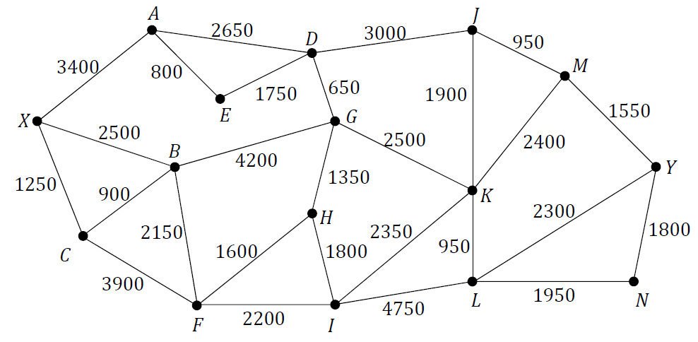

The university decides that the first part of the work will be to provide an improved route between entrance 𝑋 and entrance 𝑌. Use Dijkstra’s algorithm to find the route between 𝑋 and 𝑌 that is cheapest to improve. Calculate the cost of carrying out such improvements.

Relevant supporting work must be shown.

**2023 HL Question 2 (b)**

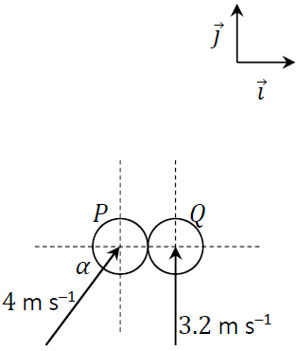Two smooth spheres, 𝑃 and 𝑄, have equal radius and are of mass 𝑚 and 2𝑚 respectively.   
𝑃 and 𝑄 collide obliquely.

The line joining their centres at the point of impact lies along the 𝚤⃗ axis.

Before the collision, sphere 𝑃 moves with a velocity of 4 m s–1 at an angle 𝛼 with the 𝚤⃗ axis, where $\sin{α}=\frac{4}{5}$.

Before the collision, sphere 𝑄 moves with a velocity of 3.2 m s–1 perpendicular to the 𝚤⃗ axis.

The coefficient of restitution between the spheres is 𝑒, where

0 ≥ 𝑒 ≤ 1.

Calculate, in terms of 𝑒, the velocity of each sphere immediately after they collide.

**2023 HL Question 3**

The photograph on the right is of a chain swing ride in an amusement park. The disk at the top of the ride is rotating in a horizontal plane.

People sit in seats which are attached freely by inextensible chains of length 4.3 m to fixed points on the disk.

The chain attaching seat 𝐴 hangs from point 𝑋 on the ride and makes an angle 𝛼 with the vertical. 𝑋 is 3.5 m from the axis of rotation, which is the vertical line 𝑃𝑄, as shown in the diagram below.

The chain is free to swing in or out relative to 𝑃𝑄.

The ride rotates about 𝑃𝑄 with constant angular velocity 𝜔. Seat 𝐴 moves in a horizontal circular path which is 6 m above the ground.

1. Draw a diagram to show the external forces acting on seat 𝐴.
2. 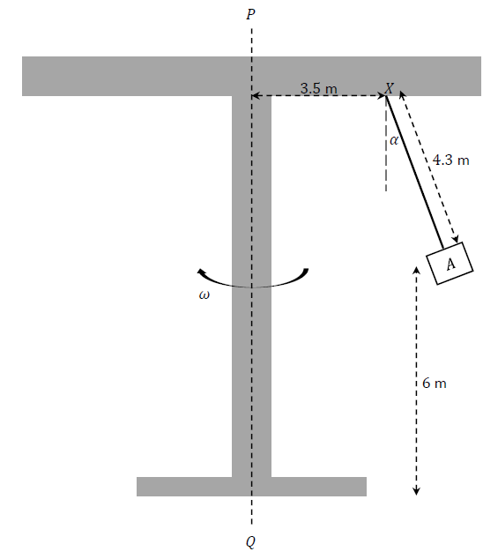Show that $ω=\sqrt{\frac{g \tan{α}}{3.5+4.3 \sin{α}}}$
3. Use dimensional analysis to show that the units for the expression $\sqrt{\frac{g \tan{α}}{3.5+4.3 \sin{α}}}$ are equivalent to the units for 𝜔.
4. It is found by measurement that 𝛼 = 25°.

Calculate how many complete revolutions the ride makes in one minute.

1. The person sitting in seat 𝐴 throws a small orange into the air. The person imparts an upward vertical velocity component of 4 m s–1 to the orange.

Calculate the time from when the orange is thrown until it hits the ground

**2023 HL Question 4**

A ball of mass 𝑚 kg is projected with initial velocity 15 m s–1 vertically downwards into a tank of water. The ball travels through the water against an upward buoyancy force that is 4 times the magnitude of the weight of the ball and a drag force of 𝑚𝑣2 N.

1. Draw a diagram to show the forces acting on the ball while it is moving downwards through the water.
2. Show that, while the ball is moving downwards, the rate of change of its velocity 𝑣 with respect to its distance 𝑠 below the surface of the water can be expressed by the differential equation:
$$v\frac{dv}{ds}=-29.4-v^{2}$$

3. Solve this differential equation to find an expression for 𝑣 in terms of 𝑠.
4. The ball is at its maximum depth, 𝐷, when 𝑣 = 0. Calculate 𝐷.
5. After reaching its maximum depth the ball changes direction and begins to move upwards through the water.

Draw a diagram to show the forces acting on the ball while it is moving upwards through the water.

1. Write down a differential equation for the rate of change of the velocity 𝑣 of the ball while it moves upwards through the water.

**2023 HL Question 5 (a)**

Block 𝑃 (of mass 6.3 kg) and block 𝑄 (of mass 2.5 kg) are held at rest on a rough surface.

They are connected by a light inextensible string which passes over a smooth fixed pulley.

Block 𝑄 lies on the horizontal part of the surface and block 𝑃 lies on the part of the surface that is inclined at 25° to the horizontal, as shown in the diagram.

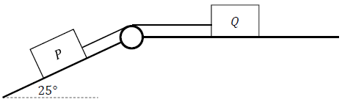

The coefficient of friction between each block and the surface is 0.2.

The blocks begin to move when they are released.

1. Show, on separate diagrams, the forces acting on the blocks while they are moving.
2. Calculate the acceleration of the blocks.

**2023 HL Question 5 (b)**

Áine travels by car from her house to work each morning.

On Monday morning she starts her car and accelerates uniformly for 40 s to a speed of 22.5 m s–1.

Áine then travels at this speed for 8 minutes until decelerating uniformly to rest at her work.   
She reaches her work at exactly 08: 30.

On Tuesday morning Áine leaves her house 140 s later than the day before.

She takes the same route to work.  
She starts her car and accelerates at 1.5 m s–2 for 20 s, then maintains this steady speed for 6 minutes before decelerating uniformly to rest at her work.

She again reaches her work at exactly 08: 30.

Calculate the time when Áine leaves her house on Tuesday morning.

**2023 HL Question 6**

Spider plants (*Chlorophytum comosum*) can reproduce asexually, producing new plants called

‘spiderettes’ or ‘pups’. The manager of a garden centre is told that a one year old spider plant produces two pups each year, that a two year old spider plant produces three pups each year, and that spider plants which are less than one year old or more than two years old do not produce any pups.

The manager predicts that 𝑈, the number of pups produced in the garden centre in any year can be expressed by the second‐order homogeneous difference equation:

𝑈*n*+2 = 2𝑈*n*+1 + 3𝑈*n*

where 𝑛 ≥ 0, 𝑛 ∈ ℤ, 𝑈0 = 1 and 𝑈1 = 2.

1. Write down the values of 𝑈2 and 𝑈3.
2. Solve the difference equation to find an expression for 𝑈*n* in terms of 𝑛.
3. Calculate 𝑈10.

The manager realises that this model does not take into account the sale of any of the spider plants produced in the garden centre. The manager decides that the garden centre will not sell any of the spider plants in either of the first two years, but that 2𝑛 of the new pups will be sold in each year 𝑛 after that.

As part of an improved model, the manager now predicts that 𝑉, the number of pups produced and retained (not sold) in the garden centre in any year can be expressed by the second‐order inhomogeneous difference equation:

*Vn*+2 = 2*Vn*+1 + 3*Vn* -2(n+2)

where 𝑛 ≥ 0, 𝑛 ∈ ℤ, 𝑉0= 1 and 𝑉1 = 2.

1. Solve this new difference equation to find an expression for 𝑉*n* in terms of 𝑛.
2. Calculate 𝑉10.

**2023 HL Question 7 (a)**

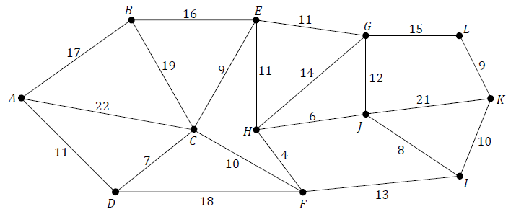There are 12 waterfalls in a certain national park. Paths allow visitors to walk from one waterfall to another. In the network shown below, the edges represent the paths and the nodes represent the waterfalls, labelled with the letters 𝐴 to 𝐿. The weight of each edge represents the time (in minutes) taken to walk between a pair of waterfalls.

The park authorities wish to plan a route along the paths which allows visitors to see every waterfall while moving through the park without wasting time. The paths that are not on this route will be closed.

1. Using an appropriate algorithm, find the minimum spanning tree for the network.

Name the algorithm you used. Relevant supporting work must be shown.

1. The park entrance is at waterfall 𝐴 and the park exit is at waterfall 𝐿. Using your minimum spanning tree, calculate the time needed to enter the park at waterfall 𝐴, visit every waterfall, and leave the park at waterfall 𝐿.

**2023 HL Question 7 (b)**

A *learning curve* is a graphical representation of how a person’s ability to perform a certain task increases with the time the person spends learning or practicing that task.

A student wishes to be able to spell 2000 difficult words. The rate of the student’s learning may be modelled by the differential equation:

$$\frac{dN}{dt}=k(2000-N)$$

where 𝑁(𝑡) is number of these words the student is able to spell after 𝑡 hours of learning, and where 𝑘 is a positive constant.

At the start of their learning the student is already able to spell 250 of these words, i.e. 𝑁(0) = 250.

1. Solve the differential equation to find an expression for 𝑁 in terms of 𝑘 and 𝑡.
2. After 6 hours of learning, the student is able to spell 1500 of these words. Calculate 𝑘.
3. Sketch the shape of a graph of 𝑁 against 𝑡 to show the model’s prediction for the student’s learning curve.
4. After 6 hours of learning, the student is able to spell 1500 of these words. Calculate 𝑘.
5. Sketch the shape of a graph of 𝑁 against 𝑡 to show the model’s prediction for the student’s learning curve.

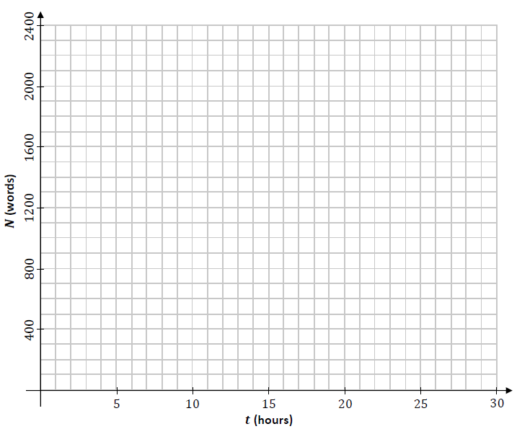

**2023 HL Question 8**

Two balls, 𝑃 and 𝑄, are projected into the air from points 𝐴 and 𝐵, which are a distance 𝐷 apart along the horizontal 𝚤⃗ axis. The motion of the balls may be modelled as projectile motion in a vertical plane, ignoring the effects of air resistance.

𝑃 is projected from point 𝐴 at time 𝑡 = 0 s with initial velocity 38 m s–1 at 41° to 𝐴𝐵.

𝑄 is projected from point 𝐵 at time 𝑡 = 1 s with initial velocity 𝑢 m s–1 at 64° to 𝐵𝐴.  
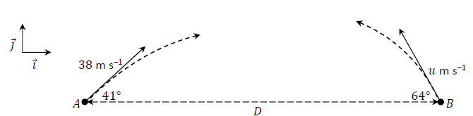

𝑃 and 𝑄 collide in mid‐air when 𝑡 = 3 s.

1. Show that 𝑢 = 28 m s–1 to the nearest whole number.
2. Calculate 𝐷.
3. In terms of 𝚤⃗ and 𝚥⃗, calculate $\vec{v_{P}}$, the velocity of 𝑃, and $\vec{v_{Q}}$, the velocity of 𝑄, when the balls collide, i.e. when 𝑡 = 3 s.
4. Calculate the dot product of $\vec{v_{P}}$ and $\vec{v_{Q}}$ when 𝑡 = 3 s.
5. Hence or otherwise calculate the acute angle between $\vec{v_{P}}$ and $\vec{v_{Q}}$ when 𝑡 = 3 s.

**2023 HL Question 9**

The manager of a regional hospital decides to arrange for the refurbishment of one of the hospital wards. The diagram below shows the scheduling network for the project.

The edges of the network represent the activities that have to be completed as part of the project and are labelled with the letters 𝐴 to 𝐿.

The duration, in days, of each activity is represented by the number in brackets. The unlabelled edges (shown with dashed lines) do not represent real activities but they help explain the order in which the activities must happen.

The letters used to label the edges should **not** be taken as representing the order in which the activities happen.

The nodes of the network represent events or points in time during the project.

The source node is the time when the project begins and the sink node is the time when the project ends.

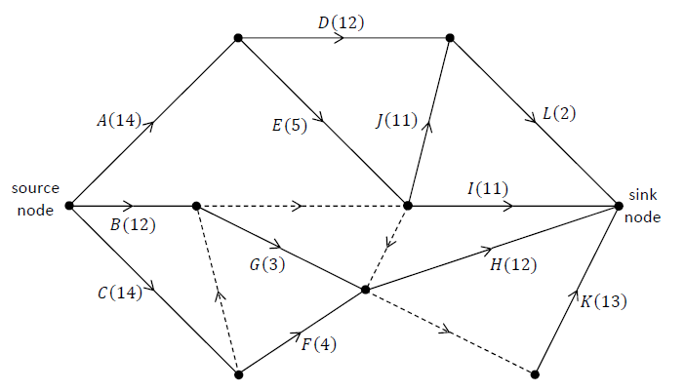

1. Complete the table on the next page by listing, for each activity, the other activities on which it depends directly. That is, for each activity 𝑋 ∈ $\left\{A, B, C, … , L\right\}$, write the smallest possible list of other activities which need to be completed before activity 𝑋 can begin.

|  |  |  |  |  |
| --- | --- | --- | --- | --- |
| **Activity** | **Depends directly on . . .** |  | **Activity** | **Depends directly on . . .** |
| ***A*** |  |  | ***G*** |  |
| ***B*** |  |  | ***H*** |  |
| ***C*** |  |  | ***I*** |  |
| ***D*** |  |  | ***J*** |  |
| ***E*** |  |  | ***K*** |  |
| ***F*** |  |  | ***L*** |  |

1. Calculate the early time and the late time for each event.

Complete the diagram below by writing the early time (upper box) and late time (lower box) at the node representing each event.

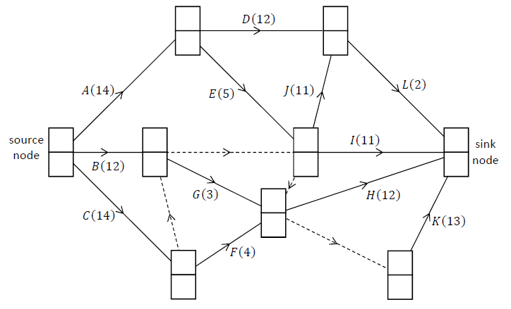

Write down the critical path(s) for the network.

A cascade chart (Gantt chart) is a type of bar chart which may be used to represent a project’s schedule. The duration of each activity is represented by the width of the horizontal bar for that activity, with time on the horizontal axis. The float time for an activity is represented by a rectangle drawn using dotted lines to the right of the bar for that activity. The top row of a cascade chart is used for a critical path.

Draw a cascade chart or similar bar chart to represent the schedule for this project.

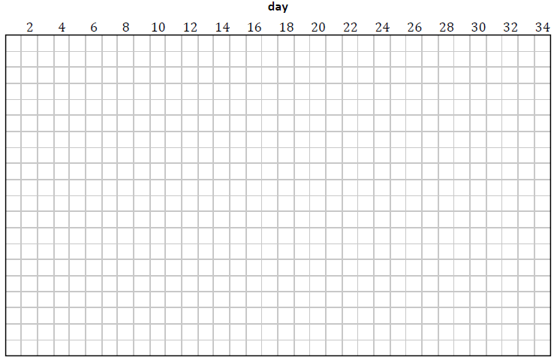

The hospital manager visits the project on day 18 to check the progress of the work, which is on schedule.

Write down the activities which may be happening on day 18.

**2023 HL Question 10 (a)**

An entomologist (a scientist who studies insects) maintains a population of grasshoppers in her laboratory.

The entomologist’s research tells her that the population of this species of grasshopper should increase by a factor of 1.2 each month if they are left undisturbed. However the entomologist removes 30 grasshoppers from the population each month, to carry out research on them.

The entomologist develops a difference equation model to predict 𝑈n, the number of grasshoppers present at the beginning of month 𝑛.

At the start of the first month the entomologist has 175 grasshoppers, i.e. 𝑈0 =175.

1. Calculate the values of 𝑈1 and 𝑈2.
2. Write down a difference equation to express 𝑈n+1 in terms of 𝑈n, where 𝑛 ≥ 0, 𝑛 ∈ ℤ.
3. Solve this difference equation to find an expression for 𝑈n in terms of 𝑛.
4. Calculate 𝑈12, the number of grasshoppers which the model predicts will be in the population after one year.

**2023 HL Question 10 (b)**

A toy car track consists of a series of components that connect to make a closed circuit.

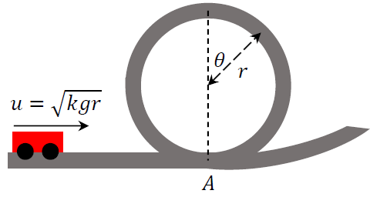Part of the track makes a vertical circular loop.

To model the motion of a car on this track, its velocity at the base of the loop (point 𝐴) is expressed as $u=\sqrt{kgr}$, where 𝑟 is the radius of the loop, 𝑔 is the acceleration due to gravity, and 𝑘 is a constant.

The model ignores the effects of friction.

1. Draw a diagram to show the forces acting on the car at the instant when the radius to the car makes an angle 𝜃 with the upward vertical.
2. If the car loses contact with the track at the instant when the radius to the car makes an angle 𝜃 with the upward vertical, show that $\cos{θ=\frac{k-2}{3}}$.
3. Calculate the minimum value of 𝑘 such that the car successfully completes the loop without losing contact with the track.