2011 Applied Maths Higher Level Questions
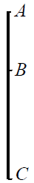
1.
(a)
A particle is released from rest at A and falls vertically passing two points B and C.
It reaches B after t seconds and takes seconds to fall from B to C, a distance of 2.45 m.
Find the value of t.

(b)
A car accelerates uniformly from rest to a speed v in t₁ seconds.
It continues at this constant speed for t seconds and then decelerates uniformly to rest in t₂ seconds.
The average speed for the journey is .
- Draw a speed-time graph for the motion of the car.
- Find t₁ + t₂ in terms of t.
- If a speed limit of were to be applied, find in terms of t the least time the journey would have taken, assuming the same acceleration and deceleration as in part (ii).

2.
(a)
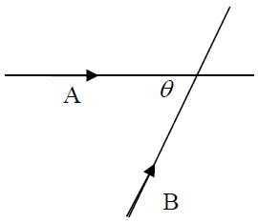
Two cars, A and B, travel along two straight roads which intersect at an angle where tan = .
Car A is moving towards the intersection at a uniform speed of 5 m s⁻¹.
Car B is moving towards the intersection at a uniform speed of 10 m s⁻¹.
At a certain instant each car is 100 m from the intersection and approaching the intersection.
Find
- the velocity of A relative to B
- the shortest distance between the cars.

(b)
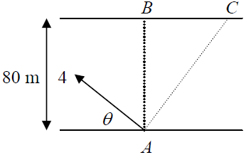
A woman can row a boat at 4 m s⁻¹ in still water.
She rows across a river 80 m wide.
The river flows at a constant speed of 3.5 m s⁻¹ parallel to the straight banks.
She wishes to land between B and C.
The point B is directly across from the starting point A and the point C is 20 m downstream from B.
If ϑ is the direction she takes, find the range of values of ϑ if she lands between B and C.

3.
(a)
A particle is projected from a point P on horizontal ground.
The speed of projection is 35 m s⁻¹ at an angle tan⁻¹ 2 to the horizontal.
The particle strikes a target whose position vector relative to P is x i+50 j
Find
- the value of x
- a second angle of projection so that the particle strikes the target.

(b)
A plane is inclined at an angle α to the horizontal.
A particle is projected down the plane with initial speed of 10 m s⁻¹ at an angle 45º to the inclined plane.
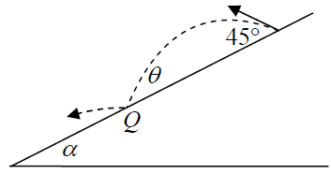
The plane of projection is vertical and contains the line of greatest slope.
The particle strikes the plane at Q with a landing angle where tan = .
- Find the value of α .
- If the magnitude of the rebound velocity at Q is5√33, find the value of e, the coefficient of restitution.

4.
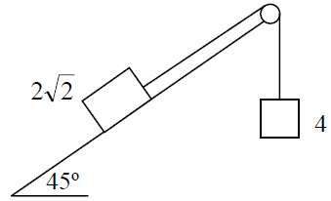
(a)
A block of mass 2 kg rests on a rough plane inclined at 45º to the horizontal.
It is connected by a light inextensible string which passes over a smooth, light, fixed pulley to a particle of mass 4 kg which hangs freely under gravity.
The coefficient of friction between the block and the plane is .
Find the acceleration of the 4 kg mass.

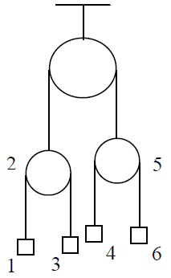

(b)
A smooth pulley, of mass 2 kg, is connected by a light inextensible string passing over a smooth light fixed pulley to a smooth pulley of mass 5 kg.
Two particles of masses 1 kg and 3 kg are connected by a light inextensible string passing over the 2 kg pulley.
Two particles of masses 4 kg and 6 kg are connected by a light inextensible string passing over the 5 kg pulley.
Find the tension in each string, when the system is released from rest.

5.
(a)
A smooth sphere P, of mass 2m kg, moving with speed u m s⁻¹ collides directly with a smooth sphere Q, of mass 3m kg, moving in the opposite direction with speed u m s⁻¹ .
The coefficient of restitution between the spheres is e and 0 < e <1.
- Show that P will rebound for all values of e.
- For what range of values of e will Q rebound?

(b)
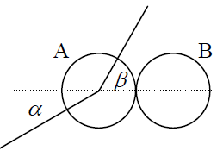
A smooth sphere A, of mass m, moving with speed u, collides with an identical smooth sphere B which is at rest.
The direction of motion of A before and after impact makes angles α and β respectively with the line of centres at the instant of impact.
The coefficient of restitution between the spheres is e.
(i) If tan α = k tan β, find k, in terms of e.
(ii) If the magnitude of the impulse imparted to each sphere due to the collision is mu cosα, find the value of e.

6.
(a)
The distance, x, of a particle from a fixed point, O, is given by
ε)
where a, ε and ω are positive constants.
- Show that the motion of the particle is simple harmonic.
- A particle moving with simple harmonic motion starts from a point 1 m from the centre of the motion with a speed of 9.6 m s⁻¹ and an acceleration of 16 m s⁻².
Calculate a, ω and ε.
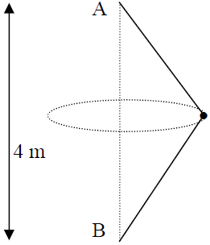

(b)
A and B are two fixed pegs.
A is 4 m vertically above B.
A mass m kg, connected to A and B by two light inextensible strings of equal length, l, is describing a horizontal circle with uniform angular velocity ω.
Find the value of ω if the ratio of the tensions in the two strings is 11: 9.

7
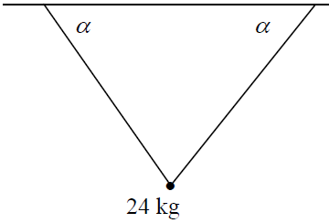
(a)
A particle of mass 24 kg is attached to two light elastic strings, each of natural length 33 cm and elastic constant k.
The other ends of the strings are attached to two points on the same horizontal level 64 cm apart.
Each string makes an angle α with the horizontal, where tan α = .
- Show that the extension of each string is 7 cm.
- Find the value of k.
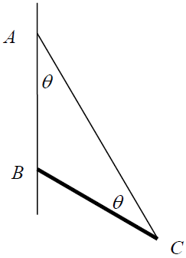

(b)
A uniform rod BC, of length 2p and weight W, rests in equilibrium with B in contact with a rough vertical wall.
One end of a light inextensible string is fixed to a point A on the wall vertically above B, the other end is attached to C.
The coefficient of friction between the rod and the wall is μ.
If the angle CAB = the angle BCA = θ , prove that μ tan

8.
(a)
Prove that the moment of inertia of a uniform square lamina of mass m and side 2l about an axis through its centre parallel to one of its sides is ml².

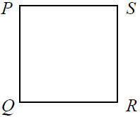
(b)
A square lamina PQRS, of side 60 cm and mass m, can turn freely about a horizontal axis through P perpendicular to the plane of the lamina.
The lamina is released from rest when PS is horizontal.
- Find the angular velocity of the lamina when PR is vertical.
- A mass m is attached to the lamina at R. The compound pendulum is set in motion.
Find the period of small oscillations of the compound pendulum and hence, or otherwise, find the length of the equivalent simple pendulum.

9.
(a)
A U-tube of cross-sectional area of 0.15 cm² contains oil of relative density 0.8.
The surface of the oil is 12 cm from the top of both branches of the U-tube.
What volume of water can be poured into one of the branches before the oil overflows in the other branch?

(b)
A uniform solid cylinder floats upright with of its axis immersed when placed in liquid A.
When placed in liquid B, the uniform solid cylinder floats upright with of its axis immersed.
What fraction of the cylinder’s axis is immersed when the cylinder floats upright in a uniform mixture of equal volumes of the two liquids?

10.
(a)
If

(b)
A particle travelling in a straight line has a deceleration of m s⁻² where v is its speed at any time t.

If its initial speed is 40 m s⁻¹, find
- the distance travelled before it comes to rest
- the average speed of the particle during the motion.

