Name:

3.5 Responses to Stimuli | Objectives  At the end of this sub section students should be able to:
3.5.3 Responses in the Human -- Nervous System  Eye & Ear | - Name the main parts of the EYE  - Give the function of each main part of the eye  - Explain what short-sightedness means  - Draw a diagram of the eye with light rays to show the problem of short sight  - Show how a lens can be used to correct short sight  - Explain what long-sightedness means  - Draw a diagram of the eye with light rays to show the problem of long sight  - Show how a lens can be used to correct long sight  - Distinguish between a convex and a concave lens  - Name the main parts of the EAR  - Give the function of each main part of the ear  - Name a hearing defect  - Explain a possible hearing disability as a result of excessive noise levels.  - Explain a corrective measure for a hearing defect

Senses = Touch, taste, smell, sight and hearing.

Sight
Structure of eye
- Sclera The white of the eye – opaque and tough.
Function - shape and protection.
- Cornea Transparent part of sclera at front of eye. Lets light in and bends it towards the retina.
- Conjunctiva Transparent membrane protecting the cornea.
- Choroid Has blood capillaries to nourish the eye and melanin (black pigment) to absorb light – ensures that there is no internal reflection of light.
- Retina Innermost layer containing the light receptors - rods and cones.
Rods | Cones
120 x 10⁶/eye | 6 x 10⁶
Detect black & white | Detect colours
Found all over the retina | Found mostly at fovea
Work in dim light | Work in bright light
- Rods contain rhodopsin (vitamin A required to form it) which breaks down in light. Cones have 3 pigments that detect blue, red and green.
- Fovea (yellow spot) - opposite centre of pupil. Contains cones only. Region of sharpest vision. Most images are formed here.
- Blind spot (no visual receptors). Area where optic nerve leaves eyeball.
- Optic nerve Carries impulses from the retina to the brain.
- Iris Coloured part of eye. Controls size of pupil and amount of light entering eye (reflex action). Its circular muscle contract to narrow the pupil in bright light to reduce the amount of light and its radial muscles contract to widen the pupil in dim light to allow more light to enter.
- Pupil Opening in the iris through which light enters the eye.
- Lens Biconvex, transparent and elastic, changes shape to focus light on to the retina. Contains a clear protein which can become cloudy (cataracts).
- Ciliary muscle Changes shape of lens.
- Suspensory ligament Attaches the ciliary body to the lens.
- Aqueous humour A watery liquid between cornea and lens, made in ciliary body - maintains eye shape; nourishes cornea and lens (these don’t have their own blood supply) and helps to refract light.
- Vitreous humour A jelly-like substance between lens and retina, gives shape to the eye

Accommodation
Changing the shape of the lens to focus near and distant objects.

- To focus a near object:
Ciliary muscle contracts, reducing tension in the suspensory ligaments (found between the ciliary muscle and the lens). This makes the lens, being elastic, more convex(fatter) to focus on near objects.
Diagram

- To focus a distant object:
Ciliary muscle relaxes, creating tension in the suspensory ligaments which makes the lens thinner for distant objects.
Diagram

Eye Defects
- Long sighted(hypermetropia) - can focus on distant objects.
With near objects light rays focus behind the retina i.e. eyeball too short or lens (or cornea) has too little curvature for the diverging rays from a near object. Corrected by a convex (converging) lens.
Diagram

- Short sighted (myopia) - can focus near objects.
With distant objects the light rays focus in front of the retina i.e. eyeball is too long or the lens (or cornea) is too curved for the distant, parallel light rays. Condition may be hereditary. Corrected by a concave (diverging) lens. Laser surgery available but there may be side effects concerning glare and night vision.
Diagram

Hearing:
Structure of ear diagram

Functions:
Hearing and balance.

Hearing
Outer Ear
Funnels sound into eardrum.
- Pinna -
Made of elastic cartilage. It collects and channels vibrations into the auditory canal.
- Auditory canal
carries vibrations to the eardrum. Wax is secreted outside the eardrum to protect the eardrum.

Middle ear
Air-filled cavity which passes vibrations form eardrum to inner ear.
- Eardrum
vibrates due to receiving sound waves.
- Ossicles
Three tiny bones in the middle ear called the hammer, anvil and stirrup. The stirrup is the smallest bone in the body. These bones transmit vibrations from the outer to the inner ear and amplify the vibrations.
- Eustachian tube
This tube links the middle ear and the pharynx (throat). It equalises air pressure on either side of the eardrum(preventing damage to eardrum). This tube is usually closed but opens with a ‘pop’ when we yawn or swallow. E.g. up a mountain where air pressure is lower there is a danger that the eardrum might be forced outwards. The Eustachian tube opens and air moves out of the middle ear. In diving air moves into the middle ear to equalize pressure caused by the water.

Inner ear
Fluid-filled cavity (lymph).
Cochlea
It converts pressure waves caused by sound vibrations into electrical impulses which travel to the brain.
- The oval window passes the vibrations into fluid-filled cochlea. The pressure waves stimulate receptors in the cochlea. These receptors are hairs which are attached to sensory cells, collectively called the organ of Corti. The receptors cause electrical impulses to be sent to the brain via the auditory nerve.
- The round window passes the vibrations out of the cochlea into the air of the middle ear..
Pitch - relates to frequency, from 16 to 20,000 Hz in humans. Pitch depends on which part of the cochlea is stimulated, high pitch (20,000Hz e.g. whistle blowing) at the base (nearest oval window)and low pitch (16 Hz e.g. drum beats) at the apex (furthest from oval window).
Loudness - relates to amplitude. Loudness depends on the number of stimulated hair cells.

Hearing disorder – know one
2 types:
Conductive - outer or middle ear
Sensorineural - inner ear

Conductive hearing loss may be due to an obstruction by a foreign body or lack of mobility of eardrum or 3 ossicles. Infections (arriving in middle ear via eustachian tube) can cause stretching or rupture of eardrum, or may prevent free movement of ossicles. Ear infections have to be taken seriously as they can cause permanent damage to cochlea or eardrum.
Glue ear - deafness in young children (of smokers!) due to a collection of sticky fluid in middle ear. It stops the ossicles from vibrating. Usually caused by a blocked eustachian tube. Corrected by removing the adenoid which may be blocking the entrance to the Eustachian tube. An opening can be made in the eardrum to drain the fluid and relieve the pressure and by inserting a grommet ( a tiny plastic tube) in the eardrum to continue draining the ear. Grommets allow air into the middle ear and this forces fluid down the Eustachian tube. In time, usually a year, the grommets fall out of the eardrum by themselves.

A sensorineural hearing loss may be due to disease of the membranes or receptors within cochlea or damage to cochlea.
One of the most common causes is exposure to continuous loud noise or sudden loud noise e.g. gunshot. This causes so much vibration that hairs in the cochlea are damaged. These are irreplaceable. Hairs nearest oval window are more likely to be damaged first. Some loss of hearing comes with age but also at a younger age from overexposure to loud noises at work e.g. pneumatic drills or rock concerts, loud music with ear phones.
Treatment:
Hearing aids. They are miniaturised amplifiers fitted into the auditory canal. They amplify sounds that the ear is less sensitive to.
A cochlear implant is a small electronic device used with severe hearing loss.
They directly stimulate undamaged nerve fibres in the cochlea. The receiver is the part implanted in the cochlea. This 1 cm disc is placed under the skin behind one ear and a wire leading from this to an electrode in the fluid of the cochlea. The headpiece consists of a microphone, to pick up the sound, and a transmitter, to send the sound to the implanted receiver. It is held in place, just behind the ear, over the receiver by magnets. The speech processor, which amplifies the sounds picked up by the microphone, is worn behind the ear or on a belt.

Balance
Balance is largely detected by the vestibular apparatus in the inner ear. It is also maintained by vision, receptors in muscles, ligaments and tendons and pressure receptors in the soles of the feet.
Semi-circular canals in the inner ear respond to movement and position of the head. These fluid filled structures keep your balance.

The utricle, saccule and semicircular canals are concerned with the balance of the body. They contain sensory hair cells which are stimulated when the position of the body is changed. These are connected to the vestibular nerve which carries the message to the cerebellum of the brain.
The semi-circular canals respond to sudden changes of motion. The saccule and utricle detect the vertical position of the head e.g. standing on your head.

Taste:
Receptors for taste are the taste buds on the tongue.
Sweet, salt, sour and bitter.
Tongue diagram

Flavour of food is a combination of taste, smell, texture and temperature.

Smell:
Olfactory neurons in nasal cavity detect smell.

Receptor cells may be neuron endings or specialized cells in close contact with neurons. Receptor cells are specialised to respond to various stimuli such as heat, light, pressure and chemicals. All these stimuli are forms of energy which the receptors absorb and convert into electrical impulses that travel along neurons.

Touch
Skin contains receptors for touch and temperature. Found in various locations and concentrations around the body e.g. few touch receptors at heel, many temp. receptors at elbow.

3.5.3 Responses in the Human – Eye & Ear

Past Paper Questions

- [SEC Sample Paper OL] [1(a)]
Complete the following sentence by putting one word in the blank space.
(a) The hammer (malleus) is a very small bone located in the ……………………………………

- [2004 OL] [15(a)]
The diagram shows the structure of the human ear.

(i) Name the parts A, B, C, D, E, F.
(ii) What is connected to the ear by D?
(iii) Which is present in G, gas or liquid?
(iv) State the function of E.
(v) State the function of F.

- [2006 OL] [15(b)]
The diagram shows a vertical section through the human eye.
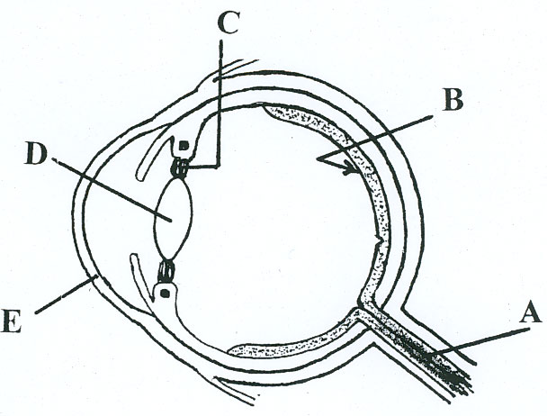

(i) Name A, B, C, D and E.
(ii) In which of these parts would you find rods and cones?
(iii) Give one function of rods and one function of cones.
(iv) What is the function of A?
(v) What type of lens is used to correct long sight? (30)

- [2008 OL] [14(b)]
(i) Copy the diagram of the front of the eye into your answer book and label the iris and the
pupil.

(ii) Is the eye shown in the diagram above adapted for dim light or bright light?
Explain your answer.
(iii) Where in the eye is the retina located?
(iv) Two types of cells that receive light are found in the retina. Name each of these.
(v) Give one difference between the two types of cell that receive light.
(vi) The optic nerve is attached to the eye. What is the function of the optic nerve?

- [2010 OL] [5]
The diagram shows the external and internal structure of the human ear.

(i) Name the parts labelled A and B.
A. ______________________________________________________________________________
B. _______________________________________________________________________________
(ii) What is the function of B? ___________________________________________________________
(iii) What is connected to the middle ear by the Eustachian tube? ________________________________
(iv) What is the function of the Eustachian tube? _____________________________________________
(v) Name one disorder of the ear or of the eye and give a corrective measure for the disorder you have named.

Disorder. _________________________________________________________________________
Corrective measure. _______________________________________________________________________
- [2011 OL] [6]
6.The diagram shows a vertical section through the human eye.
(a) Name the parts labelled A, B, C.
A. _____________________________________
B. _____________________________________
C. _____________________________________
(b) Name the coloured part of the eye.
_____________________________________________________________________________
(c) What is the function of the pupil in the eye?
_____________________________________________________________________________
(d) In which labelled part would you find the rods and cones?
_____________________________________________________________________________
(e) What is the function of the cones?
_____________________________________________________________________________

- [2013 OL] [14(c)]
(c) The diagram shows the human ear.
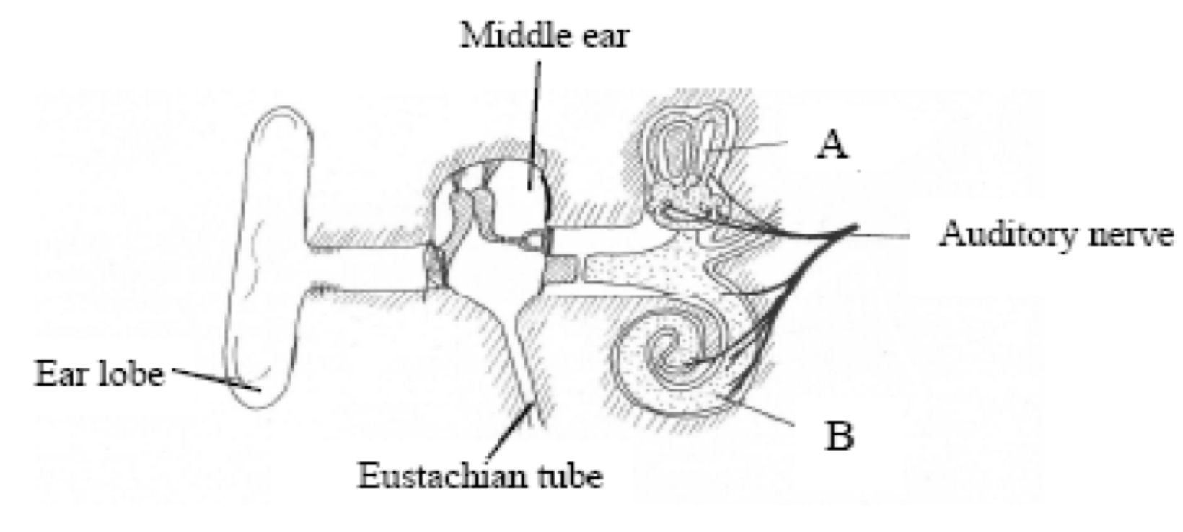
(i) Name the parts labelled A and B.
(ii) What is the function of part A?
(iii) What is the function of part B?
(iv) What is connected to the middle ear by the Eustachian tube?
(v) What surrounds the bones in the middle ear?
(vi) The ear is an example of a sense organ.
Name two sense organs, other than the ear and the eye, in the human body.
(vii) Name one disorder of the ear or of the eye and give a corrective measure for the disorder referred to.

- [2009 HL] [15(b)]
The diagram shows the human eye.
(i) Name the parts labelled V, W and X.
(ii) Give the functions of parts Y and Z.
(iii) 1.Suspensory ligaments. 2. Cones. 3. Optic nerve. 4. Brain.
Outline the roles in vision of any three of the above structures.
(iv) Explain how the iris works.
(v) Suggest a reason why two eyes are better than one.

(c) Write notes on three of the following topics:
(ii) Neurotransmitters.
- [2011 HL] [15(a)]
(a) (i) The diagram above shows the internal structure of the human ear.
1. Name the structures labelled A, B, C.
2. Give the functions of parts D and E.
3. Which letters denote the parts of the ear in which nerve impulses are generated?
(ii) In what part of the eye are nerve impulses generated?
(iii) Suggest one way by which the ear may be protected.
(iv) Explain how a corrective measure for a named defect of hearing or vision works.

Marking schemes

- [SEC Sample Paper OL] [1(a)]
Ear

- [2004 OL] [15(a)]
(i) A = malleus (hammer) (allow bone or ossicle)
B = auditory canal or outer ear
C = tympanum (ear drum)(Tympanic membrane)
D = Eustachian tube
E = cochlea
F = semicircular canals 6(3)
(ii) pharynx (throat) 3
(iii) gas 3
(iv) hearing 3
(v) balance 3

- [2006 OL] [15(b)]
(b) 4(6) + 6(1)
(i) A = (optic) nerve B = retina C = (suspensory) ligament D = lens E = cornea
(ii) Retina
(iii) Rods: black and white or vision in poor light
Cones: colour or vision in good light
(iv) Carries impulse to brain
(v) Award marks to candidates who attempt this question i.e. 15(b)

- [2008 OL] [14(b)]
(b) 3(1)+5(3)+2(6)
(i) diagram
labels (iris, pupil)
(ii) dim light
pupil large / Iris small (watch follow-on)
(iii) back of the eye / (accept behind lens)
(iv) rods/ cones Two pts
(v) rods - more numerous/ detect black and white / work
in dim light/ found all over retina
cones – less numerous/ detect colours / work in
bright light only/ found mostly in fovea
(Relate to original order)
Any one pt
(vi) carries message to brain
(
- [2010 OL] [5]
(i) A = Semi-circular canals / B = Cochlea 3(4)+4(2)
(ii) Hearing
(iii) Throat or Pharynx – allow ‘back of mouth’
(iv) To equalise pressure (on the eardrum) or air in or air out or
Protection
(v) Disorder:
Corrective measure:
- [2011 OL] [6]
3(4) + 4(2)
(a) A = Optic Nerve
B = Retina
C = Lens
(b) Iris
(c) To allow light in
(d) B or retina
(e) To detect colour / colour vision / bright light

- [2013 OL] [14(c)]
(i) A =Semicircular canals/ B = Cochlea
(ii) Balance
(iii) Hearing
(iv) Throat
(v) Air
(vi) Skin/ tongue/ nose
(vii) Disorder/ Corrective measure

- [2009 HL] [15(b)]
(i) V = Iris2
W = Pupil2
X = Choroid2
(ii) Function of Y (Lens): To focus (light) onto the retina
Function of Z (Retina): To convert light into nerve impulses
or image forms on it 3
OR
Function of Z (Vitreous Humour): Gives shape (to eye) 3
(iii) 1. Holds lens in place or (involved in) changing shape of lens
2. (Detects) colour (or explained)
3. Brings impulses from retina or brings impulse to brain
4. Interprets information (received from retina) Any three 3(3)
(iv) (muscular) contraction 3
in response to light intensity or pupil size changes or allows more
(or less) light in
(v) Increased visual field or to judge distance (depth) or 3D vision 3
(accept other reasonable suggestion) 3
- [2011 HL] [15(a)]
(i) 1. A = cochlea 2
B = eardrum 2
C = auditory nerve 2
2. Function of:
D = posture or balance 3
E = pressure equalisation 3
3. A 3
D 3
(ii) Retina or named part of retina 3
(iii) Skull (or bone) or wax or wear ear protection or avoid noisy environments 3
(iv) Named defect 3
Corrective measure or how this works to correct named defect 3

Activities on eye
Work in pairs. Do activity and discuss results. Fill in on sheet.

- Eye dominance:
Align pencil, at arm’s length, with a vertical object. Close and open left eye, then right eye.

What happens?___________________________________________________________

Which eye do you use for alignment? __________________________________________

Why?__________________________________________________________________

- Double vision
Keep both eyes open and concentrate on square. Rest finger on upper eyelid at outer corner of less dominant eye and press.

What happens?__________________________________________________________________

Why happens when you disturb normal alignment of the eyes?__________________________________

Binocular vision
- Hold a pencil upright in front with both eyes open. Then bring a needle/finger on to the top of the pencil. Close one eye and repeat.
What do you notice? ______________________________________

Why is it difficult to judge the distance? _________________________________
- Point thumb at your nose and note what you see with the left eye, right and both
Left eye__________________________________________________________________________

Right eye_________________________________________________________________________

Both_____________________________________________________________________________.

- Blind spot
Close left eye and concentrate on cross with right eye and slowly bring page to face.

- Inverted image
Fill a round-bottomed flask with water. Hold it up to the window and view an object outside e.g. tree.

What do you notice?______________________________________________________________

Why does this happen? _____________________________________________________________

What happens when you look at small print under the microscope?

________________________________________________________________________________________

- Iris reflex response
Look at pupils. Close eyes for 30 secs and look at the pupils.
What do notice when your partner opens their eyes first? _________________________________________

And after a while?_____________________________________________________________________

Why do you think this happens?_____________________________________________________________

What effect have drugs/alcohol on pupils?_______________________________________________________

- Any others you know?

- What type of vision do you have?

- What does 20/20 vision mean?

- Have you worn contact lenses/glasses?

Why did you need them?

- What is the part of the eye which prevents reflection of light in the eye

- Why is the pupil in the eye black?

- What are the effects of the following types of light on the pupil?

Bright Light:__________________________________________________________

Dim Light:____________________________________________________________

- Explain the following:
Conjunctivitis:

Cataracts:

Melanin:

Accomodation:

Astigmatism:

Myopia

Astigmatism is when the cornea has different curvatures in different directions - barrel-shaped.
Vision can be blurred at all distances and may have eyestrain and poor concentration.
Correction- glasses/contact lenses.

Lazy eye - due to poor central vision in one eye only. Usually develops before the age of 6.
Treatment - eye exercises and eye patches. Early diagnosis leads to a full recovery, otherwise treatment is difficult. Condition never corrects itself.

20/20 vision is a term used to describe perfect visual sharpness. It means that someone can see at 20 feet what should be seen at 20 feet. 20/50 vision means that you have to be at 20 feet to see what you should see at 50 feet.

- Eye dominance:
Align pencil, at arm’s length, with a vertical object. Close and open left eye, then right eye.
Note change in apparent position of pencil.

Only one eye, the dominant eye, is used for the alignment, even though eyes were open. When the dominant eye is closed, the pencil will appear to jump sideways.
- Double vision
Keep both eyes open and concentrate on square. Rest finger on upper eyelid at outer corner of less dominant eye and press.

Disturbing normal alignment of the eyes prevents fusion of the two images and thus double vision occurs.

Binocular vision
(1) Hold a pencil upright in front with both eyes open. Then bring a needle/finger on to the top of the pencil. Success. Close one eye and repeat.... Fails. Difficult to judge the distance.

(2) Point thumb at your nose and notice the different images of your hand produced with the left eye, right and both (note back/palm/3D view of hand).
Stereoscopic vision - visual fields of two eyes overlap and each has a slightly different viewpoint. This gives a 3-D impression of the object and a sense of depth and distance.

- Blind spot
Close left eye and concentrate on cross with right eye and slowly bring page to face. Note dot disappearing at the blind spot.

When the image of the gap falls on the blind spot, the line appears to be continuous.

- Inverted image
(1) Make a pinhole in a card and hold it as close to your eye as possible. Look through the hole and slowly move a pin upwards between your eye and the hole. The pin appears to move down. Move the pin for right to left - the image moves from left to right.
(2) Candle/pinhole/screen - note image is upside down and back to front (as on film).

Candle/pinhole/screen in a shaded room- adjust distances between each to get inverted image.

- Iris reflex response
Dark/bright light - note size of pupils (i.e. pupils dilate/constrict). In dim light, radial muscles in iris contract and circular muscles relax. This increases size of pupil and lets more light in. Many drugs like alcohol and atropine, block the contraction of the circular muscles and leave the eyes temporarily dilated.
Shine a light into one eye with the other closed. Note that both pupils contract together.

Note:
Sheep’s eye -
Cut the eye into a front half and a back half.
Look through the dissected lens and note that images are opposite down.

Colour vision and colour deficiency
3 types of cones sensitive to 3 primary colours - red, green and blue
Colour blindness occurs in 8% of men and 0.4% of women. Most common condition is red-green colour deficiency.

