**Chapter 30:** **The Atom, the Nucleus and Radioactivity**

***Please remember to photocopy 4 pages onto one sheet by going A3→A4 and using back to back on the photocopier***

***Never trust an atom. They make up everything.***

In the early 1900’s the most popular model of the atom was ‘the plum pudding’ model; which assumed that the atom is composed of electrons surrounded by a soup of positive charge to balance the electron's negative charge, like negatively-charged ‘plums’ surrounded by positively-charged ‘pudding’.

**Ernest Rutherford’s gold foil experiment**

In 1909 the New Zealand physicist Ernest Rutherford carried out the following experiment;

He fired alpha particles at a very thin sheet of gold foil.

The alpha particles could be detected by small flashes of light that they produced on a fluorescent screen (see diagram).

He found that*:

* Most alpha particles were undeflected and passed straight through the gold foil.
* Some were deflected through small angles.
* A very small number were turned back through angles greater than 900!

Obviously this couldn’t be explained using the ‘plum pudding’ interpretation.

Instead Rutherford interpreted his results as follows:

* The atom is mostly empty space, but there is a solid centre, which has a positive charge.

We now know that the radius of a nucleus is about 10-15 m, while the radius of an atom is about 10-10 m*.

* The electrons orbit the nucleus.

*Just to give you some sense of what this means; one teaspoon of water contains more atoms than the atlantic ocean contains teaspoons of water.*

We now know that the positive nucleus consists of positively-charged protons and along with neutrons, which have no charge (neutral).

Similar charges repel, so why are a bunch of similarly-charged particles (protons) hangin’ around together in the nucleus?

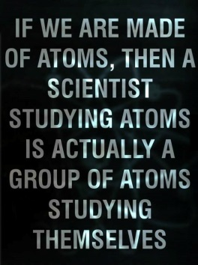Patience my little one, patience. The answer to this lies in the final chapter, *Particle Physics*.

**The atomic number (Z)** of an atom tells us the number of protons present in the atom*.

**The mass number (A)** of an atom tells us the number of protons *plus neutrons* present in the atom.

**Isotopes** are atoms which have the same Atomic Number but different Mass Numbers.

**Bohr Model of the atom\***

There was one major problem with Rutherford’s picture of the atom. He envisaged that the electrons orbited the nucleus in a manner similar to planets orbiting the sun; they could be at any distance from the nucleus and have any amount of energy. But when the boffins looked at this mathematically they quickly realised that this wasn’t possible. If the electrons were moving in a circular path then the maths suggested that they should be losing energy and therefore would very quickly spiral into the nucleus. And this wasn’t happening.

The Danish physicist Neils Bohr developed his theory of the arrangement of the electrons along the following lines:

1. Electrons could only inhabit certain discrete levels or orbitals.
2. If an electron absorbs energy (in the form of heat or light) then it can ‘jump’ to a higher orbital or energy state.
3. This state is unstable and therefore temporary.
4. When the electron ‘falls’ back down to a lower state it emits electromagnetic radiation of frequency f, corresponding to a packet of energy (photon) of size**hf** **= E2 – E1** where E2 and E1 are the energies associated with the two electron levels and h is a constant known as Planck’s constant.
5. Each transition has a definite energy and therefore a definite colourIf this radiation is in the visible part of the electromagnetic spectrum then we see it as light of a specific colour.

**Bohr won a Nobel Prize for this work, and in particular for coming up with the mathematical link between energy and frequency (E = hf).**

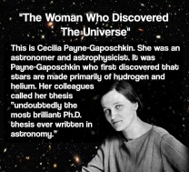

**Emission spectrums**

A simple gas like hydrogen has a number of unique energy transitions and these correspond to various colours visible when viewing the gas through a diffraction grating or spectrometer.   
The different colours correspond to the frequency of the electromagnetic radiation emitted.

This series of lines is known as an emission spectrum.   
Each element has its own unique emission spectrum (you could say that they have their very own barcode).   
This is how scientists first spotted that the sun is mainly hydrogen and helium.   
In fact helium was discovered on the sun *before* it was discovered on Earth.

Hence its name comes from *Helios* - the Greek Sun god. We both know that I googled that.

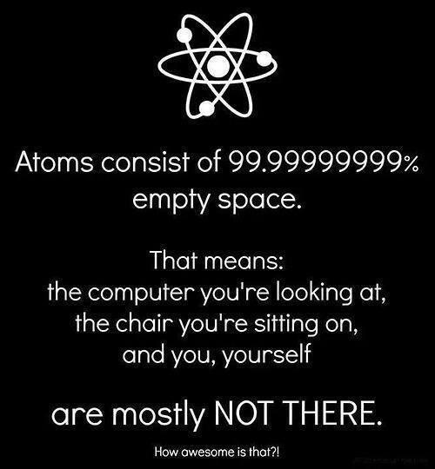

**Radioactivity**

**Radioactivity** is the breakup of unstable ***nuclei*** with the emission of one or more types of radiation*.  
You must specify *nuclei*, not *atoms*.

*However, relatively stable (and therefore non-radioactive) atoms can be made radioactive by bombarding them with neutrons.*

These are known as **artificial** **radioactive isotopes**, and are often used in industry for the following;

|  |  |  |
| --- | --- | --- |
| Medical Imaging | Food irradiation | Radiocarbon dating |
| Medical Therapy | Agriculture | Smoke Detectors |

**Ionisation** occurs when an atom loses or gains an electron**.**

**An ion** is a charged atom.

**Alpha, beta and gamma radiation**

The three different types of radiation emitted during radioactive decay are called alpha, beta and gamma radiation.

**Alpha Radiation (α)**

**An alpha particle is identical to a helium nucleus (2 protons and 2 neutrons).**

Since they have a relatively large charge they cause a lot of ionisation as they pass through a material.

Consequently they lose their energy quickly and their penetrating ability is poor.

Charge = +2

Note that the mass number of the parent atom decreases by four and its atomic number decreases by two.

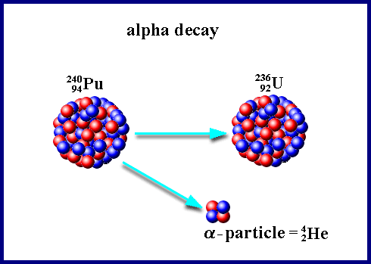Example 1:

We say that the particles on the right are ‘daughter products’.

Example 2 [2016 HL]  
A polonium–212 nucleus decays spontaneously while at rest, with the emission of an alpha-particle.   
What daughter nucleus is produced during this alpha-decay?

Solution

$${}_{84}^{212}{Po} →{}_{2}^{4}{He+ {}_{?}^{?}X}$$ The total number on top on the left must equal the total number on top on the right.

The same applies for the bottom.

Once you realise that the atomic number of the daughter product is 82 you then go to the periodic table of elements to identify this atom – it this case the element ‘lead’ has an atomic number of 82

$${}_{84}^{212}{Po} →{}_{2}^{4}{He+ {}_{82}^{208}{Pb}}$$

**Beta Radiation (β)**

**In this case a neutron splits up into an electron and a proton (and a neutrino)!!*:**

$${}_{0}^{1}n→{}_{-1}^{0}e+{}_{1}^{1}p$$

Notes:

The *–1* below the electron symbol obviously doesn’t represent an atomic number; it is merely a little accounting trick used to check if the (atomic) books are balancing.

A beta particle is therefore identical to a *fast moving* electron.

You must include the term ‘fast moving’.

They are less ionising and therefore more penetrative than alpha particles.

Charge = -1

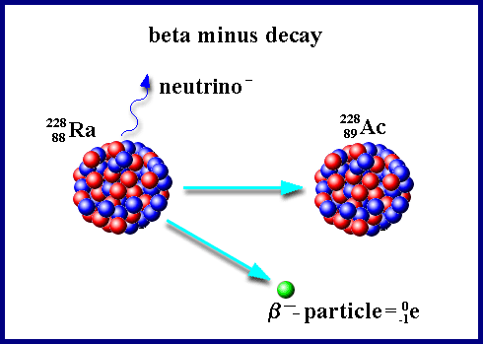

Example 1:

Example 2 [2005]:

Cobalt−60 is a radioactive isotope and emits beta particles.

Write an equation to represent the decay of cobalt−60.

Solution

$${}_{27}^{60}{Co}→{}_{-1}^{0}e+{}_{?}^{?}X$$

The total number on top on the left must equal the total number on top on the right.

The same applies for the bottom.

Once you realise that the atomic number of the daughter product is 28 you then go to the periodic table of elements to identify this atom – it this case the element ‘Nickel’ has an atomic number of 28

$${}_{27}^{60}{Co}→{}_{-1}^{0}e+{}_{28}^{60}{Ni}$$

**Gamma Radiation (γ)**

**Gamma radiation is radiation of very short wavelength (and therefore high frequency and therefore high energy (from E =hf)).**

It is uncharged and so its ionising ability is relativity poor but it is highly penetrating.

There is no change in atomic number or mass number, so there is no equation as such.

Gamma radiation usually only accompanies alpha and beta decay.

**Can you identify the three sources X, Y and Z from the information in this diagram?**



**Half-Life**

**The half-life\*** (T1/2) of an element is the time taken for half the radioactive nuclei in the sample to decay.

The number of disintegrations per second is often referred to as ‘the activity’.

The symbol for ‘Activity’ is A.

**The *unit* of activity is the Becquerel (Bq).**

Note thatthisis just a single number.

**One Bq = one disintegration per second.**

This leads to a second (alternative) definition for half-life:

**The half-life** (T1/2) of an element is the time taken for the activity (of that sample) to be halved.

Obviously, the more atoms that are present, the greater will be the activity (the number of disintegrations per second).

This is summed up by *the Law of Radioactive Decay.*

**The law of radioactive decay** states that the *activity* is proportional to the number of nuclei present.

Mathematically: Activity ∝ N

**A = λ N**

⇒

Where N = number of nuclei present and λ is called the *decay constant*. The unit of decay constant is *s-1*.

In maths questions the activity can be referred to in a number of various ways:

1. *the number of disintegrations per second*
2. *the decay rate / the rate of decay*
3. *the number of particles emitted per second*
4. *the number of particles undergoing decay per second*

There is also a relationship between *half-life* (T½) and the *decay constant* (λ)

$T_{1/2}=\frac{ln 2}{}$**or $T_{1/2}=\frac{0.693}{}$**

**Maths questions**

Maths questions on radioactivity are a little like comprehension questions; you need to read the question a couple of times and then underline each relevant point of information.

Remember there are only two formulae: **A = λ N** and $T_{1/2}=\frac{0.693}{}$

**Detecting Radiation: the Geiger-Muller Tube**

**Operation**

Principle: A charged particle passing through a gas leaves in its wake a trail of electron-ion pairs, like a bull in a china shop. The electrons then accelerate up to the anode where they get detected as an electronic pulse.

1. 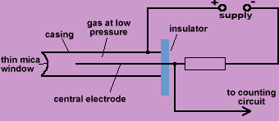Radiation enters through the thin window on the left.
2. It causes ionisation of some of the rare-earth gas molecules inside.
3. The negative ions (electrons) accelerate towards the anode, colliding off (and ionising) other gas molecules along the way, giving rise to an avalanche effect.
4. These ions all reach the anode more or less together and are detected as a pulse.
5. The G-M tube may in turn be connected to a counter or loudspeaker or (in our case) both.

**Using a G-M tube to investigate the range of Alpha, Beta and Gamma radiation in air**

Or

**To identify three different sources**

1. Get the background count.
2. This is done by first setting the counter to zero without any radiation source nearby and then recording the number of counts over a 5-minute period.
3. From this calculate the number of counts per second.
4. Place the alpha source in front of the detector.
5. Find the average count rate per second.
6. Move the detector away from the source in small steps and calculate the average count rate at each step.
7. Continue until count rate equals background count rate.
8. Repeat for Beta source and Gamma source.

**Result**

The Gamma radiation will be detected at the greatest distance (from source to detector), and Alpha radiation the least.

**Note**

We could also have tested the penetrative ability of the different sources in a similar fashion, ie by placing different materials between source and detector.

We would find that a few sheets of paper would stop Alpha, Aluminium would be required for Beta, while lead is necessary for Gamma radiation.

**To demonstrate the ionizing affect of radioactivity**



Procedure: Bring a radioactive source close to the cap of a charged Gold Leaf Electroscope

Observation: Leaves collapse

Conclusion: The charge on the G.L.E. became neutralised by the ionised air.

**Maths Questions**

* For **radioactivity and nuclear physics**data on the mass of isotopes and half-lives is on pages 83 to 93.
* Note that page 83 does not include some of the elements of higher atomic number; these are given on page 82.
* **Particle Physics data** is on pages 48 - 49.
* Use the same degree of accuracy as the figures in the question and do not round off the mass of nuclei when doing mass-energy calculations.

**How might radiation (which is in the air all around us) lead to lung cancer?**

Radon gas (mainly from granite rock) is the main source of background radiation, which in turn is responsible for almost all the radiation we get exposed to over our lifetime. The problem occurs when we breathe in; some of the radioactive atoms in the gas undergo radioactive decay and emit alpha, beta or gamma radiation. These in turn can collide with and ionise atoms in our lung tissue, which can damage our DNA in the tissue of the cells, which could ultimately lead to lung cancer.

**The effect of Ionising Radiation on humans depends on**

1. The type of radiation (whether it’s alpha, beta or gamma)
2. The activity of the source (in Bq)
3. The time of exposure
4. The type of tissue irradiated

**Precautions when dealing with ionising radiation**

1. Make sure sources are properly shielded.
2. Keep sources as distant as possible from human contact, eg use a pair of tongs (and not, as one official safety brochure advised, a pair of thongs).
3. Use protective clothing.

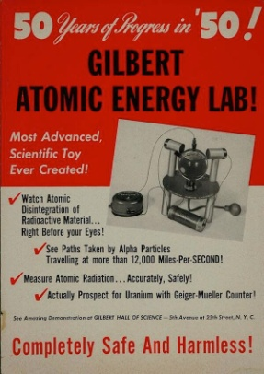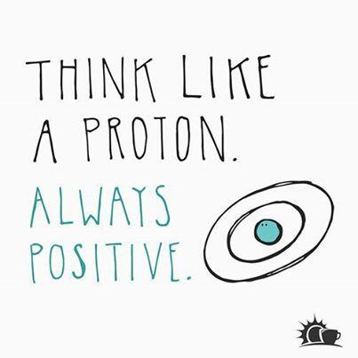

**Leaving Cert Physics Syllabus**

|  |  |  |  |
| --- | --- | --- | --- |
| **Content** | **Depth of Treatment** | **Activities** | **STS** |
|  |  |  |  |
| The Nucleus |  |  |  |
| 1. Structure of the atom | Principle of Rutherford’s experiment.  Bohr model; descriptive treatment only.  Energy levels  Emission line spectra.  Hf = E2 – E1 | Experiment may by simulated using a large-scale model *or* a computer *or* demonstrated on a video.  Demonstration of line spectra and continuous spectra. | Lasers.  Spectroscopy as a tool in science. |
|  |  |  |  |
| 2. Structure of the nucleus | Atomic nucleus as protons plus neutrons.  Mass number A, atomic numbers Z, ${}_{Z}^{A}X$ isotopes. |  |  |
|  |  |  |  |
| 3. Radioactivity | Experimental evidence for three kinds of radiation; by deflection in electric or magnetic fields or ionisation or penetration.  Nature and properties of alpha, beta and gamma emissions.  Change in mass number and atomic number because of radioactive decay. | Demonstration of ionisation and penetration by the radiations using any suitable method, e.g. electroscope, G-M tube. | Uses of radioisotopes:  medical imaging  medical therapy  food irradiation  agriculture  radiocarbon dating  smoke detectors  industrial applications. |
|  |  |  |  |
|  | Principle of operation of a detector of ionising radiation. Definition of Becquerel (Bq) as one disintegration per second. | Demonstration of G-M tube or solid state detector.  Interpretations of nuclear reactions. |  |
|  |  |  |  |
|  | **Law of radioactive decay.**  Concept of half-life T1/2  **Concept of decay constant**  **Rate of decay = λN**  **T½ = ln 2 / λ** | **Appropriate calculations**  **Appropriate calculations** |  |
|  |  |  |  |
| 4. Nuclear Energy | Dealt with in next chapter |  |  |
| 5. Ionising radiation and health hazards | General health hazards in use of ionising radiations, e.g. X-rays, nuclear radiation; the effect of ionising radiation on humans depends on the type of radiation, the activity of the source (in Bq), the time of exposure, and the type of tissue irradiated. | Measurement of background radiation.  Audiovisual resource material. | Health hazards of ionising radiation.  Radon, significance of background radiation, granite.  Medical and dental X-rays.  Disposal of nuclear waste.  Radiation protection. |

**Extra Credit**

**Some quotes:**

***In science there is only physics; all the rest is stamp collecting.***

Lord Rutherford.

***The energy produced by an atom is a very poor kind of thing. Anyone who expects a source of power from the transformation of these atoms is talking moonshine.***

Rutherford.

***We must be wary of using this word ‘transmutation’ – lest people believe us to be alchemists*.**

When Rutherford split the atom he was quite literally changing one element into another – the goal of alchemists down through the years .Alchemists used all sorts of potions to try to turn lead into gold. They were also interested in creating something called *the elixir of life* – supposed to be responsible for eternal youth. They tended to use urine as a raw material rather a lot. All in all, rather a strange bunch – a bit like our modern day chemistry teacher.

***I have observed many transformations in my work on radioactivity, but none so rapid as my own transformation from a physicist to a chemist*”**

Rutherford again, this time on receiving the Nobel Prize for Chemistry (hate that!).

Something most textbooks are uncomfortable with is the fact that the great Isaac Newton spent over 90% of his time as an alchemist.

One noted historian claimed that ***Newton was not the first great scientist; he was the last of the great mystics.***

***\*He found that . . .***

Now while Rutherford was indeed a brilliant physicist, do not think that these ideas came easily to him.

For every one experiment that was productive, he had probably another 90 that were a waste of time.

See for example the video ‘Rutherford’s Atom’, available in the physics lab.

Indeed when he carried out this experiment he had no idea what the result would be. He described his astonishment at the results in very graphic terms:

***“It was quite the most incredible event that ever happened to me in my life. It was as incredible as if you fired a 15-inch shell at a piece of tissue paper and it came pack and hit you!”***

Rutherford puzzled over these results *for some weeks* and eventually realised that the alpha particles could only be scattered through such large angles if they had collided with a very dense and small core of matter within the atom – the atomic nucleus.

"These transformations of the atom are of extraordinary interest to scientists but we cannot control atomic energy to an extent which would be of any value commercially, and I believe we are not likely ever to be able to do so... Our interest in the matter is purely scientific, and the experiments which are being carried out will help us to a better understanding of the structure of matter."  
Rutherford in a letter to Nature, 1933.

Ooops . . .

**\*Bohr model of the atom**

Shortly after 1900 the brothers Niels and Harald Bohr of Denmark became famous soccer players in Scandinavia.

In 1908 Harald won a silver medal in the first Olympic soccer competition.

Bohr was raised in a middle class Danish family and showed no particular talent as a child except for sports.

He played soccer at almost a professional level and was an active skier until late in his life.

Niels' son Aage was also a Nobel physicist.

**\*We now know that the radius of a nucleus is about 10-15 m, while the radius of an atom is about 10–10 m.**

Therefore the radius of an atom is 100,000 times bigger than that of a nucleus.  
And volume of a sphere is proportional to the cube of the radius.

This means that all matter is actually 99.99999999999 % empty space.

So if we removed all the empty space in the body, we would we left with all the mass taking up a volume about the same as a grain of sand!

Now, given that your fist is made up of atoms (which as we have seen are pretty much just empty space) why doesn’t your fist go straight through a table (which is just as empty) when you hit it?

Also, if you and I are almost completely empty space, why do we give the appearance of being solid?

AND WHY THE HELL DON’T WE DISCUSS THIS??

***\*The atomic number (Z) of an atom tells us the number of protons present in the atom.***

Because the activity of an atom is determined by the number and arrangement of electrons, it is sometimes said that “protons give the atom its identity; electrons give it its personality”. Nice.

***\*Isotopes are atoms which have the same Atomic Number but different Mass Numbers.***

For example Carbon-12 has 6 protons and 6 neutrons, while carbon-14 has 6 protons and 8 neutrons.

Therefore Carbon-12 and Carbon-14 are isotopes.

***1932: Chadwick discovers the neutron***

For four years, James Chadwick was a prisoner of war in Germany. When World War I ended, he returned to his native England to rejoin the mentor of his undergraduate days, Ernest Rutherford. Now head of Cambridge University's nuclear physics lab, Rutherford oversaw Chadwick's PhD in 1921 and then made him assistant director of the lab.

Chadwick's own research focused on radioactivity. In 1919 Rutherford had discovered the proton, a positively charged particle within the atom's nucleus. But they and other researchers were finding that the proton did not seem to be the only particle in the nucleus.

As they studied atomic disintegration, they kept seeing that the atomic number (number of protons in the nucleus, equivalent to the positive charge of the atom) was less than the atomic mass (average mass of the atom). For example, a helium atom has an atomic mass of 4, but an atomic number (or positive charge) of 2. Since electrons have almost no mass, it seemed that something besides the protons in the nucleus were adding to the mass. One leading explanation was that there were electrons and additional protons in the nucleus as well -- the protons still contributed their mass but their positive charge was canceled out by the negatively charged electrons. So in the helium example, there would be four protons and two electrons in the nucleus to yield a mass of 4 but a charge of only 2. Rutherford also put out the idea that there could be a particle with mass but no charge. He called it a neutron, and imagined it as a paired proton and electron. There was no evidence for any of these ideas.

Chadwick kept the problem in the back of his mind while working on other things. Experiments in Europe caught his eye, especially those of Frederic and Irene Joliot-Curie. They used a different method for tracking particle radiation. Chadwick repeated their experiments but with the goal of looking for a neutral particle -- one with the same mass as a proton, but with zero charge. His experiments were successful. He was able to determine that the neutron did exist and that its mass was about 0.1 percent more than the proton's. He published his findings with characteristic modesty in a first paper entitled "Possible Existence of Neutron." In 1935 he received the Nobel Prize for his discovery.

His findings were quickly accepted and Werner Heisenberg then showed that the neutron could not be a proton-electron pairing, but had to be its own unique particle -- the third piece of the atom to be found. This new idea dramatically changed the picture of the atom and accelerated discoveries in atomic physics. Physicists soon found that the neutron made an ideal "bullet" for bombarding other nuclei. Unlike charged particles, it was not repelled by similarly-charged particles and could smash right into the nucleus. Before long, neutron bombardment was applied to the uranium atom, splitting its nucleus and releasing the huge amounts of energy predicted by Einstein's equation E = mc2.

[**http://www.pbs.org/wgbh/aso/databank/entries/dp32ne.html**](http://www.pbs.org/wgbh/aso/databank/entries/dp32ne.html)

***\*Radioactivity is the disintegration of unstable nuclei with the emission of one or more types of radiation.***

I *think* that the greater the discrepancy between the number of protons and the number of neutrons, the more radioactive an element is.

It seems that the discrepancy causes the nucleus to become unstable.

Also, the higher up the periodic table you go, the greater will be the discrepancy and therefore there is a greater likelihood that these elements will be radioactive.

So to recap; the nuclei of some atoms are unstable and as a result break up to form more stable nuclei.

These new nuclei may in turn break up further.

If we know what type of atom it is, we will be able to predict the changes which will take place within the nucleus.

But here’s the kick:

There is absolutely no way of knowing ***when*** an individual atom will decay, **AND** there is absolutely no way of affecting the process.

Or to put it a bit more scientifically, the decay process is unaffected by physical or chemical factors. So you can hit the atom with a kango hammer, dip it in a bath of sulphuric acid, heat it with a blow-torch or caress it softly while whispering sweet nothings in its ear – it won’t make any difference. It will decay when and only when it’s good and ready.

It is a truly random or spontaneous event (as opposed to tossing a coin for instance).

For what it’s worth, this has serious philosophical implications as it sets a limit to how much science can ever know.

So There!

***\*In this case a neutron splits up into a proton and an electron (and a neutrino)***

I have to admit that I always grimace when I read this in text-books.

It’s as if this is the most natural thing in the world, like Kerry winning the All-Ireland. The phrase represents all that is wrong with physics textbooks – no wonder people think physics is boring.

Let’s take a look at this again. “A neutron splits up into a proton and an electron”. Now we know electrons do not, as a rule, live inside neutrons.

In fact they have nothing at all to do with the nucleus of an atom.

They *orbit* the damn thing.

*AND* an electron is charged, a neutron is not.

*AND* a neutron only has quarks in it, and quarks and electrons are completely different (it says so in the textbook).

So how/why can a neutron spit out an electron?

Now there have been some strange births in our time - there have been cases of women giving birth to a baby which in turn had a foetus inside her.

There have been reports of a woman giving birth to a child without any conception having taken place – but I’ve never, EVER heard of anything stranger than a neutron giving birth to an electron and a proton.

Maybe it’s just me.

But here’s the thing.

Once the process doesn’t break any of the laws of physics (e.g. conservation of energy, charge, momentum etc).then it’s allowed, and apparently this process doesn’t break any.

By the way;

Don’t make the mistake of assuming that the neutron is actually a proton and an electron bound together, which come apart.

That idea was rejected in the 1930s.

***The Neutrino***

Beta decay also includes the emission of another particle called the neutrino, which wasn’t discovered until decades later, so for some reason we ignore it in this chapter but include it when studying the *Particle Physics* chapter.

***\*Half-Life***

One of many analogies for half-life is the Gold Leaf Electroscope.

They are very easily broken.

In fact, after every 40-minute class using them, approximately half of them need to be repaired.

It is (almost) impossible to predict in advance which electroscopes will break (although one could take a look at the students involved and make an educated guess from there).Assuming the broken ones do not get repaired, then the half which are still in working order get handed out in the next class.

After 40 minutes, half of these come back broken.

And so on. You could say that the half-life of a gold leaf electroscope is 40 minutes.

We can say the same about the decay of a large number of radioactive atoms (of the same element).

If the element is Radon, then after a certain time approximately half of the atoms will have decayed.

This time will be the same for Radon no matter how many atoms are present (assuming that there are a very large number). It’s a lot like saying that if I toss a coin it will come up heads half the time. This will only be accurate if we are talking about a very large number of coin tosses.

The time it takes half of the radon atoms to decay is unique to radon and is called the half-like of radon.

Each element has its own unique half-life.

Protactinium-234, for instance, has a half-life of 1.2 minutes, while Uranium-238 has a half-life of 4.5 billion years!

See the chain below for more examples.

**Did you know?**

Each cubic metre of garden top soil contains typically:

0.5 grams of Uranium and the members of its decay chain.

1.5 grams of Thorium and the members of its decay chain.

Brazil nuts contain small amounts of radium, a radioactive material. Although the amount is very small, about 1–7 pCi/g (40–260 Bq/kg), and most of it is not retained by the body, this is 1,000 times higher than in other foods. According to Oak Ridge Associated Universities, this is not because of elevated levels of radium in the soil, but due to "the very extensive root system of the tree."  
Source: Wikipedia

A 70 kg human has about 9 kBq of natural radioactivity; mostly K-40 and C-14.

**Polonium**

Marie Curie discovered a new element while working on radioactivity.

At the time (circa 1900) her country was in danger of being annexed by Germany. Fearing nobody would ever remember that her country had even existed, she called the new element Polonium so we would never forget.

Her notebooks are still so radioactive that they are kept in lead cases!

**Does *any* increase in exposure to radiation cause an increase in the risk of getting cancer?**

Short answer:

We don’t know.

Long answer:

There is no dispute that radiation can cause DNA damage and that such damage is an initiating event in cancer development. Single-strand breaks are easily repaired however while studies have shown that this is not the case with double-strand breaks.

The linear no-threshold (LNT) theory assumes that *any* exposure to radiation carries a risk of developing cancer. It is widely applied by radiological protection agencies and endorsed by the International Commission on Radiological Protection (ICRP).

On the other hand breaks in the genetic code inside the cell are commonplace and quickly repaired. On average there are up to 150,000 breaks per cell daily. We already have a background of DNA breaks and any contribution to this total by radiation may be minor or indeed negligible.

**Scientists discover new element**



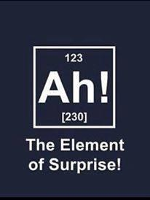**Radiation Experiments in the U.S.**

Radiation Experiments were carried out in the United States under the auspices of the American Department of Defense, Department of Energy and the Atomic Energy Commission between 1944 and 1974 on around 20,000 people. Many were subjected to the experiments without their consent. The experiments were carried out by both military officials and civilian doctors and scientists and were intended to study the short- and long-term effects of radiation exposure.

They varied widely, according to the report in the *British Medical Journal*, from direct injections of uranium, polonium and plutonium into unsuspecting patients, to the irradiation of prisoners’ testicles to the deliberate release of radiation into the atmosphere. For example, isotope injections were given to 18 patients between 1945 and 1947 who had been admitted with various disorders including hepatitis, dermatitis, ulcers, heart attacks and Addison’s disease.

The US federal government had now announced that it will pay £3.2 million in compensation to survivors of experiments which were part of one particular research programme, developed to gain an understanding of the biological consequences of biological warfare. These experiments violated the Nuremberg code because in most cases the patients were unaware of what was happening and they were not only unlikely to derive any therapeutic benefit but were subjected to potential harm.

*Irish Independent* 02/12/1996

**Decay Chains**

The daughter nuclide of a decay event may also be unstable (radioactive). In this case, it will also decay, producing radiation. The resulting second daughter nuclide may also be radioactive. This can lead to a sequence of several decay events. Eventually a stable nuclide is produced. This is called a *decay chain*.

An example is the natural decay chain of uranium-238 which is as follows:

decays, through alpha-emission, with a half-life of 4.5 billion years to thorium-234

which decays, through beta-emission, with a half-life of 24 days to protactinium-234

which decays, through beta-emission, with a half-life of 1.2 minutes to uranium-234

which decays, through alpha-emission, with a half-life of 240 thousand years to thorium-230

which decays, through alpha-emission, with a half-life of 77 thousand years to radium-226

which decays, through alpha-emission, with a half-life of 1.6 thousand years to radon-222

which decays, through alpha-emission, with a half-life of 3.8 days to polonium-218

which decays, through alpha-emission, with a half-life of 3.1 minutes to lead-214

which decays, through beta-emission, with a half-life of 27 minutes to bismuth-214

which decays, through beta-emission, with a half-life of 20 minutes to polonium-214

which decays, through alpha-emission, with a half-life of 160 microseconds to lead-210

which decays, through beta-emission, with a half-life of 22 years to bismuth-210

which decays, through beta-emission, with a half-life of 5 days to polonium-210

which decays, through alpha-emission, with a half-life of 140 days to lead-206, which is a stable nuclide.

Some radionuclides may have several different paths of decay. For example, approximately 36% of [bismuth-212](http://en.wikipedia.org/wiki/Bismuth-212), decays, through alpha-emission, to thallium-208 while approximately 64% of [bismuth-212](http://en.wikipedia.org/wiki/Bismuth-212) decays, through beta-emission, to [polonium-212](http://en.wikipedia.org/wiki/Polonium-212). Both the [thallium-208](http://en.wikipedia.org/wiki/Thallium-208) and the [polonium-212](http://en.wikipedia.org/wiki/Polonium-212) are radioactive daughter products of [bismuth-212](http://en.wikipedia.org/wiki/Bismuth-212), and both decay directly to stable [lead-208](http://en.wikipedia.org/wiki/Lead-208).

Source: Wikipedia

**Exam questions**

**The atom**



1. [2002][2008 OL]
2. The diagram shows a simplified arrangement of an experiment carried out early in the 20th century to investigate the structure of the atom. Name the scientist who carried out this experiment.
3. Describe what was observed in this experiment.
4. Why was it necessary to carry out this experiment in a vacuum?
5. What conclusion did the scientist form about the structure of the atom?
6. [2005]

Rutherford had bombarded gold foil with alpha particles. What conclusion did he form about the structure of the atom?

1. [2009][2005][2008 OL]

What is the structure of an alpha particle?

1. [2008 OL]

How are the electrons arranged in the atom?

1. [2006]

Describe the Bohr model of the atom.

1. [2007]

Describe how an emission line spectrum is produced.

1. [2008]

When the toaster is on, the coil emits red light.

Explain, in terms of movement of electrons, why light is emitted when a metal is heated.

1. [2007][2003][2009 OL]

What is an isotope?

1. [2002 OL]

Give two examples of radioisotopes.

1. [2003]

How many neutrons are in a 14C nucleus?

**Radioactivity**

1. [2003][2003 OL]

What is radioactive decay?

1. [2004 OL][2005 OL][2007 OL][2010 OL]What is radioactivity?
2. [2009 OL]
3. Name the three types of radiation.
4. Which radiation is negatively charged?
5. Which radiation has the shortest range?
6. Which radiation is not affected by electric fields?
7. [2004 OL]

Name the French physicist who discovered radioactivity in 1896.

1. [2002 OL]What is measured in becquerels?
2. [2003][2002 OL][2005 OL]Apart from “carbon dating”, give two other uses of radioactive isotopes.
3. [2002 OL]

Give two examples of radioisotopes.

1. [2008][2007][2003 OL][2004 OL][2005 OL][2007 OL][2008 OL][2009 OL]

Name an instrument used to detect radiation/ alpha particles/ measure the activity of a sample.

1. [2008][2007][2004 OL]

What is the principle of operation of this instrument?

1. [2004 OL] [2005][2010 OL]

Give two uses of a radioactive source.

1. [2005]

Nuclear disintegrations occur in radioactivity and in fission.

Distinguish between radioactivity and fission.

1. [2005]

Radioactivity causes ionisation in materials. What is ionisation?

1. [2005]

Describe an experiment to demonstrate the ionising effect of radioactivity.

1. [2004 OL]
2. The diagram illustrates that three types of radiation are emitted from a radioactive source. Name the radiations labelled (i) X, (ii) Y, (iii) Z, in the diagram.
3. Which one is the most ionising?
4. ****[2010 OL]
5. The diagram shows a shielded radioactive source emitting nuclear radiation.

How do you know that the source is emitting three types of radiation?

1. Name the radiation blocked by each material

**Half-life**

1. [2007][2002 OL][2005 OL]

Explain the term half-life.

1. [2005 OL]

Na−25 is a radioactive isotope of sodium. It has a half life of 1 minute.

What fraction of a sample of Na−25 remains after 3 minutes?

1. [2007 OL]

The half life of a radioactive element is 3 days.

What fraction of a sample of the radioactive element will remain after 9 days?

1. [2004]

The activity of a radioactive isotope decays to 1/16th of its original value after 36 years.

What is the half-life of the isotope?

1. [2007]

An ancient wooden cup from an archaeological site has an activity of 2.1 Bq.

The corresponding activity for newly cut wood is 8.4 Bq.

If the half-life of carbon-14 is 5730 years, estimate the age of the cup.

1. [2003]

14C is a radioactive isotope of carbon with a half-life of 5730 years.

How much of a 14C sample remains after 11 460 years?

1. [2006]

A neutral pion is unstable with a decay constant of 2.5 × 1012 s–1. What is the half-life of a neutral pion?

1. [2009]

Americium-241 has a decay constant of 5.1 × 10–11 s–1.

Calculate its half life in years.

1. [2003[

14C is a radioactive isotope of carbon with a half-life of 5730 years.

Calculate the decay constant of 14C.

1. [2005]
2. Cobalt−60 is a radioactive isotope with a half-life of 5.26 years.

Calculate the decay constant of cobalt−60.

1. Calculate the rate of decay of a sample of cobalt−60 when it has 2.5 × 1021 atoms.
2. [2007]

When a tree is cut down the carbon-14 present in the wood at that time decays by beta emission.

Write a nuclear equation to represent the decay of carbon-14.

1. [2003]

14C decays to 14N. Write an equation to represent this nuclear reaction.

1. [2005]

Cobalt−60 is a radioactive isotope and emits beta particles.

Write an equation to represent the decay of cobalt−60.

1. [2007 OL]

Read this passage and answer the questions below. Radon is a naturally occurring radioactive gas. It originates from the decay of uranium, which is present in small quantities in rocks and soils. Radon is colourless, odourless and tasteless and can only be detected using special equipment, like a Geiger-Müller tube, that can measure the radiation it releases. Because it is a gas, radon can move freely through the soil and enter the atmosphere. When radon reaches the open air, it is quickly diluted to harmless concentrations, but when it enters an enclosed space, such as a house, it can sometimes accumulate to unacceptably high concentrations. Radon can enter a building from the ground through small cracks in floors and through gaps around pipes and cables. Radon is drawn from the ground into a building because the indoor air pressure is usually lower than outdoors. Being radioactive, radon decays releasing radiation.When radon is inhaled into the lungs the radiation released can cause damage to the lung tissue.

(Adapted from Understanding Radon, A Householder’s Guide by the RPII.)

1. What is the source of radon?
2. How does radon enter a building?
3. How can the build-up of radon in the home be prevented?
4. Why is radon dangerous?
5. Why is radon harmless in the open air?
6. Name a radioactive element other than radon.
7. [2003]

Why does the 12C in dead tissue remain “undisturbed”?

1. [2002 OL]

What is meant by background radiation?

1. [2010]

Name the naturally occurring radioactive gas which seeps into buildings from underground rocks and which can cause lung cancer.

1. [2003 OL][2004 OL][2010 OL]

Give two precautions that are taken when storing the plutonium / dealing with radioactive sources.

1. [2004 OL][2002 OL][2010 OL]

Give two effects of radiation on the human body.

1. [2009]

Smoke detectors use a very small quantity of the element americium-241. This element does not exist in nature and was discovered during the Manhattan Project in 1944.

Alpha particles are produced by the americium-241 in a smoke detector.

1. How are the alpha particles produced?
2. Why do these alpha particles not pose a health risk?
3. Explain why americium-241 does not exist naturally.

{I don’t think this was a fair question and shouldn’t have appeared on the paper}

**Extra Questions**

1. What is ionising radiation?
2. How does radiation cause cancer?
3. Why is non-ionising radiation considered to not be as dangerous as ionising radiation?
4. What about mobile phone radiation?

**Exam solutions**

1. Ernest Rutherford.
2. Most alpha particles passed straight through; some were deflected by various amounts and a small percentage bounced back completely.
3. To prevent the alpha particles colliding with other particles.
4. It consists of a small, dense, positively charged core with negatively charged electrons circling around it.
5. The atom was mostly empty space with a dense positively-charged core and with negatively-charged electrons in orbit around it.
6. An alpha particle is identical to a helium nucleus (composed of 2 protons and 2 neutrons).
7. They orbit the nucleus at discrete levels.
8. A dense positively-charged nucleus with the negatively-charged electrons in orbit at discrete levels around it.
9. When the gas is heated the electrons in the gas are move up to higher orbital level and as they fall back down they emit electromagnetic radiation of a specific frequency.
10. Electrons gain energy and jump to higher energy. Then when they fall back down they emit electromagnetic radiation in the form of light.
11. Isotopes are atoms which have the same atomic number but different mass numbers.
12. Iodine, caesium, radon, carbon 14, etc.
13. Eight
14. Radioactive decay is the breakup of unstable nuclei with the emission of one or more types of radiation.
15. Radioactivity is the breakup of unstable nuclei with the emission of one or more types of radiation.
16. Alpha (α), beta (β) and gamma (γ).
17. Beta (β)
18. Alpha (α)
19. Gamma (γ)
20. Henri Becquerel (you shouldn’t have been asked this).
21. Rate of decay, activity of a radioactive substance.
22. Medical imaging, (battery of) heart pacemakers, sterilization, tracers, irradiation of food, killing cancer cells, measuring thickness, smoke detectors, nuclear fuel, detect disease, detect leaks.
23. Iodine, caesium, radon, carbon 14, etc.
24. Geiger Muller tube.
25. Incoming radiation causes ionisation of the gas.
26. Carbon dating, radiotherapy, sterilising medical equipment, killing bacteria in food, smoke alarm
27. Radioactivity is the breakup of unstable nuclei with the emission of one or more types of radiation.

Nuclear Fission is the break-up of a large nucleus into two smaller nuclei with the release of energy (and neutrons).

1. Ionisation occurs when a neutral atom loses or gains an electron.
2. Apparatus: radioactive source and charged (gold leaf) electroscope

Procedure: bring radioactive source close to the cap

Observation: leaves collapse

Conclusion: charge leaks away through ionised air / electroscope neutralised by ionised air

1. X = alpha, Y = gamma, (iii) Z = beta.
2. Alpha.
3. One type stopped by the paper, 2nd by the aluminium and the 3rd by the concrete.
4. paper blocks alpha / α,

aluminium blocks beta/ β,

concrete blocks gamma/ γ

1. Time for half the radioactive nuclei in a sample to decay
2. After one minute half has decayed and half remains, after 2 minutes (2 half-lives) ¾ has decayed and ¼ remains; after 3 minutes 7/8ths has decayed and 1/8th remains.
3. After 3 days (one half-life) ½ would remain, after 6 days (two half –lives) ¼ would remain, and after 9 days (three half-lives) ⅛ would remain.
4. 1 → 1/2 →1/4 →1/8 → 1/16 = 4 half-lives

Answer: 9 years

1. 8.4 Bq to 2.1 Bq requires two half-lives.

Answer =11,460 years

1. 11,460 corresponds to two half lives, and after two half lives one quarter remains.
2. T1/2 = ln 2 (= 0.693) /λ

T1/2 = 0.693 / 2.5 × 1012

T1/2 = 2.8 ×10-13 s

1. T½ = 0.693 / λ  T½ = 0.693 / 5.1 × 10–11  T½ = 1.36 × 1010 seconds = 430.6 years
2. T1/2 = ln 2 /λ  λ = 0.693/5730 = 1.21 × 10−4 y-1 = 3.8×10−12 s-1
3. Formula: T1/2 = ln 2/λ  λ = ln 2/T1/2

*T1/2* = 5.26 y = 1.66 × 108 s and ln 2 = 0.693

λ = 0.693/ 1.66 × 108   λ = 4.18 × 10-9 s-1

1. dN/dt = (-) λN = (4.18 × 10-9)( 2.5 × 1021) = 1.04 × 1013 Bq
2. 146C → 714N + -10e ( accept *e* in lieu of β)
3. 146C → 714N + -10e
4. 
5. Uranium, radium, rocks, soil.
6. Through small cracks, through the floor, through gaps around pipes
7. By installing a radon membrane, installing a depressurising unit, sealing cracks, sealing gaps, having good ventilation, etc.
8. It can cause damage to lung tissue (it can cause cancer).
9. It is diluted (to harmless concentrations)
10. Uranium, radium, plutonium, carbon 14, etc.
11. It is not radioactive, it is not exchanging with the atmosphere, it is stable.
12. Radiation which is in the environment due to rocks/cosmic radiation.
13. Radon (gas)
14. Use thick shielding, use a tongs, use protective clothing, etc.
15. Cancer, skin burns, sickness, cataracts, cause sterility, genetic, etc.
16. α-decay is produced when the americium (which is radioactive) undergoes radioactive decay.
17. They have a very short range so are either contained within the smoke detector itself or just travel a cm or two through the air.
18. Its half life is very short (with respect to age of the universe) and because it is not a member of a decay series it is not produced ‘in nature’ (it is created artificially).

**Fun activities**

Suspend a large hula hoop from the ceiling of the classroom.

Suspend a ball bearing at the centre of this (use string or wire and glue).

Fire tennis balls / balls of paper at the ball bearing; most of the ‘particles’ will just pass right through, much like the majority of alpha particles appear to pass through the gold foil.

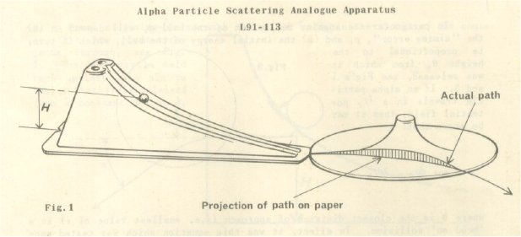You can also purchase the following from science suppliers like timestar which is another model of Rutherford’s experiment.

Did you know?

The repulsion force acting on each proton in the nucleus is approx 200 N.  
This is what lead scientists to postulate the existence of a second stronger force; it was some time before there was other evidence for the strong force.

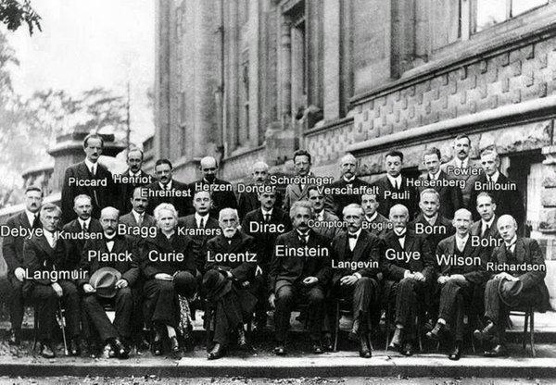

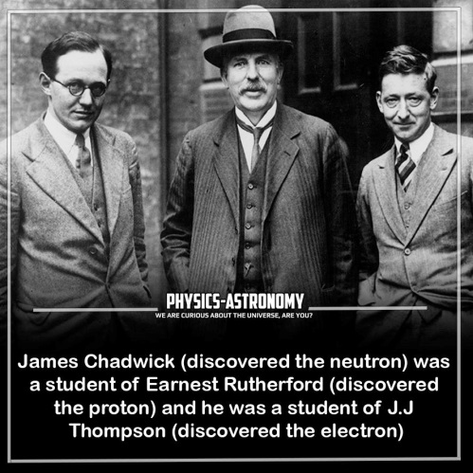**A generation of scientists at the Solvay Conference, 1927**