**Chapter 10.2: Gravity**

***Please remember to photocopy 4 pages onto one sheet by going A3→A4 and using back to back on the photocopier.***

**Questions to make you think**

1. An apple falls from a tree due to the force of gravity acting on the tree. However the earth also experiences a force of gravity due to the existence of the apple.

Which experiences the greater force (the apple or the planet)? Why?  
Which experiences the greater acceleration? Why?

1. Why do two objects with different masses fall at the same rate? After all, we know from Newton’s law that the force between two objects is proportional to the product of their masses, so for example the force between the Earth and a *1 kg* mass is 1000 times greater than the force between the Earth and a *1 gram* mass.
2. Imagine there is a hole going from the top of the earth right out the other side. You see this hole, and not having any sense worth talking about, decide to jump in. Describe how your weight changes as you fall.
3. Astrologers claim that the position of the planets at the moment of birth can have a big influence on your future. Which has the greater gravitational influence – a planet or a nurse standing at the side of your bed?  
   Justify all calculations.
4. **Why is there no atmosphere on the moon?**

Answer: The gravitational force is too weak to sustain an atmosphere.  
NB: If you say “gravity” is too weak you will not get full (or possibly any) marks.

**Student Notes**

**Newton’s Law of Gravitation\***

states that any two point masses in the universe attract each other with a force that is directly proportional to the product of their masses, and inversely proportional to the square of the distance between them.



G (known as ‘big G’) is a constant: its value is 6.7 x 10-11 N m2 kg-2 (you don’t need to know this).

*I desire you do not ascribe innate gravity to me … that one body may act upon another at a distance is to me so great an absurdity, that I believe no man who has in philosophical matters a competent faculty of thinking, can ever fall into it.*

Newton

Newton simply couldn’t get his head around why the force of gravity should exist at all. In his monumental work *Principia* he went to great lengths to point out that his treatment of motion would be a mathematical treatment only:

*The words “attraction”, “impulse” or any “propensity” towards a centre, however, I employ indifferently and interchangeably, considering these forces not physically but merely mathematically. The reader should hence beware lest he think by words of this sort I anywhere define a species or mode of action, or a physical cause of reason.*

In a separate letter to a friend he writes:

*You sometimes speak of gravity as essential as inherent to matter. Pray do not ascribe this notion to me, for the cause of gravity is what I do not pretend to know and therefore would take more time to consider it.*

... *If one asks why one thing draws another - It is answered by "a certain drawingness it hath"'.*

As for Lord Kelvin, well he flatly stated - "Present science has no right to attempt to explain gravitation. We know nothing about it. We simply know NOTHING about it",

But Newton’s gravitational law did have one thing going for it – it worked.

**Gravity and weight**

It turns out that weight and mass are related by the following formula (nobody is quite sure why):

W = mg

*Weight* (as we have seen from the chapter on *Force*) is merely a shorthand way of saying *force due to gravity*.

Therefore we could re-write W = mg, as Fg = mg {where Fg represents force due to gravity}

But we have just seen above that 

We can equate both equations to get  = mg

Now on the left hand side one of these masses (m1) represents the mass of the Earth (or any other planet).

m2 represents the mass of a second object, while on the right hand side m also represents the mass of this object.

So cancelling this m on both sides (corresponding to the mass of the object) we get



This lets us calculate acceleration due to gravity (*g*) at any distance from a given planet.

It also allows us to calculate the answer to the following common exam question: *Yo mamma’s so fat that objects 10 m away accelerate towards her at a rate of 1 m s-2. What’s yo mamma’s mass?*

Note that these three formulae are in page 56 of the log tables.



**The word ‘mass’ actually means two very different things in physics**

1.

The mass of an object is a measure of the resistance which the object has to a change in its velocity.

This is known as *inertial mass* and we can calculate it using the formula *a = F/m* (from *F = ma*).

2.

The mass of an object determines the size of the gravitational attraction between that object and any other object.

This is known as *gravitational mass* and we can calculate it using *m=W/g* (from *W = mg*).

Incredible though it may seem, these two separate concepts have the same value and therefore both have the same unit assigned to them – the kilogram. Obviously this can’t be just a coincidence, but nobody has been able to explain it – yet.

For what it’s worth, we did come across this already, back in the chapter on *Force, mass and momentum*:

Mathematically weight = mass × gravitational field strength

(where *gravitational field strength* is a measure of the strength of the Earth’s gravitational field at that point).

**W = mg**

The units of gravitational field strength are N/kg (can you see why?).

Now it just so happens (nobody is quite sure why) that the value of *gravitational field strength* is the same as the value for *acceleration due to gravity* (9.8 m s-2 on the surface of the Earth). So you will often see the relationship above written in textbooks where *g* is said to represent acceleration due to gravity (with units of m s-2). The number may be the same, but *g* most definitely does not represent acceleration due to gravity in this context.

The textbooks also suggest that *W = mg* follows ‘naturally’ from the equation *F = ma*. They do look similar so you can see why some might think this, but if you apply that thinking to a book on a table then its weight should be zero because it’s not accelerating.

Incidentally, the fact that both concepts have the same value is known as *the equivalence principle*, and we use it to explain why objects of different mass fall at the same rate.

Why do we always gloss over such mysteries?

**Leaving Cert Physics Syllabus**

|  |  |  |  |
| --- | --- | --- | --- |
| **Content** | **Depth of Treatment** | **Activities** | **STS** |
|  |  |  |  |
| Gravity | Newton’s law of universal gravitation. | Compare gravitational forces between Earth and Sun and between Earth and Moon. | Solar System. |
|  | Weight = mg |  |  |
|  | **Variation of g, and hence W, with distance from centre of Earth** | **Appropriate calculations.** | **“Weightlessness” and artificial gravity.** |
|  | Value of acceleration due to gravity on other bodies in space, e.g. Moon. | Calculation of weight on different planets. | Presence of atmosphere. |

**Extra Credit**

**\*Newton’s Law of Gravitation**

States that any two point masses in the universe attract each other with a force that is directly proportional to the product of their masses, and inversely proportional to the square of the distance between them.

Mathematically: FG ∝ (M1 M2),

And F ∝

Putting this together 

Where G is a constant, as mentioned above.

This means that each of us is ‘attracted’ to every one of our colleagues, and the bigger they are, the greater is our attraction!

Contrary to what you may have thought, it also means that you are more likely to be attracted to your average American than to a person of any other nationality on this planet (Samoans excepted).

So there.

So when you ‘drop’ your keys and the planet pulls them down towards the ground, which experiences the bigger force of attraction; your keys or the planet?

Answer: the force of attraction is the same. Can you see why?

So why doesn’t the planet accelerate up towards the keys?

Of course the fact that Newton spent over 90 % of his research on the very unscientific pursuit of alchemy, or that he actually invoked deity to nudge the planets back in line whenever his law wasn’t providing a full explanation doesn’t tend to make it into the text-books.

He also got into some nasty disputes with some of his fellow scientists, and wasn’t above cogging results from others and claiming them as his own. But that’s another story.

**Physics and Astrology**

We can use this law to test one of the fundamental concepts in astrology; how strong is the (gravitational) influence of a planet (or the moon) on a new-born baby compared to the influence of a near-by building?

Stick the numbers into the formula above and see for yourself!

**Physics and Chaos**

So we can use this to predict the motion of any planet due to the existence of another neighbouring planet. The next challenge was to see if it was possible to come up with an equation which would allow for the motion of a planet due to existence of *two* other planets.

Scientists quickly realised that this was an incredibly complex problem and was impossible to solve with the maths tools available to them at that time.

It was one of the first examples of what we now call *Chaos Theory*. The underlying rules were simple but the process rapidly becomes very complex. Scientists have made a lot of progress in this area since the advent of the computer. There is a wonderful documentary (available on YouTube) called ‘The Colours of Infinity’ which explains Chaos Theory much better than I ever could. By the way, Chaos Theory explains why the weather can never be predicted more than 13 days in advance, regardless of what local experts will tell you.

**Hooke and Newton**

Robert Hooke (remember Hooke’s Law?) was probably Britain’s foremost scientist (or ‘natural philosopher’ as they were then known) when Newton first came to prominence. Over the following years the men became bitter enemies, to the extent that when Newton replaced Hooke as president of the Royal Society in England, the painting of Hooke which had pride of place in the building mysteriously went ‘missing’ shortly after Newton replaced him.

One reason they fell out was because Hooke was a mechanist. He believed that it was the scientist’s job to engage with nature’s causes – the cause of light, of gravity and so on – and how these causes produce effects that we can detect with instruments. Newton, on the other hand, saw physics as concerned with the mathematical expression of effects. For Newton the true causes of nature, being divine, were beyond the business of science.

The truth is, Newton could describe gravity, but he didn’t know how it worked. “Gravity must be caused by an agent acting constantly according to certain laws,” he admitted. “But whether this agent be material or immaterial, I have left to the consideration of my readers.”

After Newton died scientists went to a lot of trouble to promote him as the person to whom all other scientists should aspire. So they downplayed his interest in both astrology and alchemy. They would also have been uncomfortable with the role which he believed God played in maintaining the motion of the heavens. Sometimes they went a little overboard. One Victorian biographer noted that in addition to his intellectual contribution, Newton’s life was ‘one continual source of labour, patience, charity, generosity, piety, goodness and all other virtues, without a mixture of any vice whatsoever’.

Hmmm. . .

Nevertheless, as I go on to explain in another chapter (Circular Motion) Newton’s big achievement was to show that the motion of the heavens did actually follow rules of Physics and so could be predicted. It was this which later led Einstein to comment that “the most incomprehensible fact about the world is that it is comprehensible”.

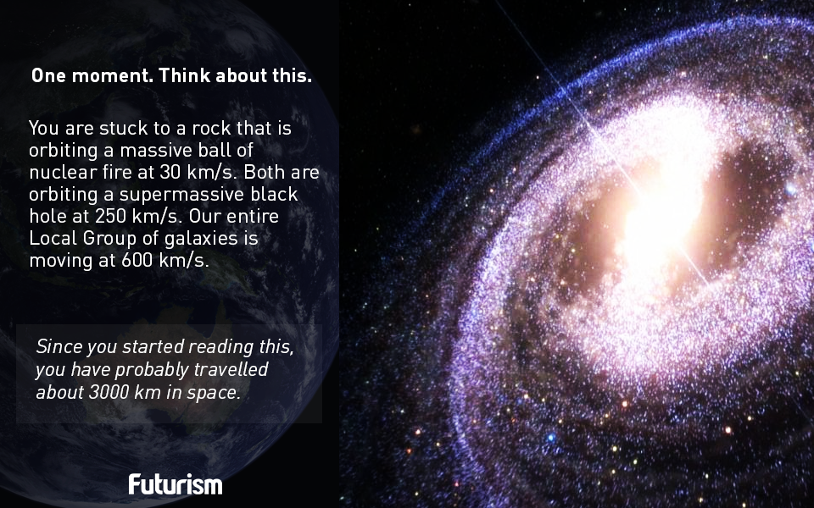

**What’s in a word - what *is* gravity?**

The reason apples fall to the ground is because of ‘gravity’.

Yes the term ‘gravity’ is what we use to label the phenomenon, but does tell us anything new?

After all, I’m sure the word preceded Issac Newton, so why did he feel that there was anything left to explain?

Anytime I mention this in class I am invariably met with a set of puzzled faces, so in an effort to illuminate the problem I draw a picture of the planet Earth, with an apple tree on top, and an apple hanging out of it.

Now everyone knows that when the apple falls it will fall ‘down’ to Earth. What happens next is very interesting;

Students don’t see that there is anything to explain about why an apple falls to the ground – it’s just the way it’s meant to be (harking back to Aristotelian notions).

Now draw an upside-down apple tree underneath the Earth and have an apple in mid-air. Which way does it fall? An upside-down stick figure might help them appreciate what’s going on. It’s still pretty amazing though. Now complicate things just a little by saying the man has just spilt a cup of tea – what will happen? You may find that our language causes confusion here. Does the apple ‘fall up to the ground’? What does this tell us about the words ‘fall’ and ‘up’?

The apple which ‘falls up’ may now need a little explanation. It’s at this stage that the resident nerd declares confidently ‘That’s easy, gravity pulls the apple to earth’, and unfortunately, as with most nerds, he’s right. But wait. One simple question can now cause the rest of your class plan to go out the window (there’s a moral in there somewhere). “What is gravity”? Now at this stage a series of hands may go up because everyone knows what gravity is; it’s what causes objects to be pulled to Earth. Now it’s time to explain what a tautology is.

But back to the apple.

Hopefully by now those of you still reading this will know where I’m heading. Knowing *about* the word ‘gravity’ and knowing what gravity *is* are two rather different concepts.

I personally know very little about what gravity *is*. I could try to sound impressive throwing out terms like *gravitational field, gravitons, superstring theory, relativity, space-time* and the like, but that would be little better than what I was correcting the students over.

Instead what I prefer to do is to highlight the fact that Newton himself was very uncomfortable with talking about what gravity actually was. What he did was to show mathematically some of rules which govern how gravity works. He came up with a formula which would predict the force of attraction between any two masses, and because everybody thought that Newton was so brilliant they decided to call his formula a Law, which sounds much more impressive (well almost everybody thought he was brilliant. how and why Newton was promoted as (one of?) science’s first secular saints is another story).

Which brings us nicely back to the apple. Newton has many claims to fame, but perhaps one of his greatest achievements was acting as a signpost to all other scientists, showing them how science *should* be carried out. There should be no reference to divine intervention, every claim should be amenable to being verified by experiment. This was why he was so uncomfortable talking about *why* gravity worked. How did the apple *know* that the earth was beside it? Somehow this information must have been transferred across the space between them, but did it take time or was it instantaneous?

**Exam Questions**

Universal gravitational constant (G) = 6.7 x 10-11 N m2 kg-2

Radius of the earth = 6.36 × 106 m Acceleration due to gravity at the earth’s surface = 9.81 m s−2

Distance from the centre of the earth to the centre of the moon = 3.84 × 108 m

Mass of the earth is 6.0 × 1024 kg

1. [2004][2005][2008][2008 OL][2010] State Newton’s law of universal gravitation.
2. Give two factors which affect the size of the gravitational force between two bodies. [2006 OL]
3. Complete the table

|  |  |  |  |
| --- | --- | --- | --- |
| Mass 1 | Mass 2 | distance | Force of attraction |
| 10 kg | 10 kg | 1 m |  |
| Mass of earth = 6.0 × 1024 kg | Mass of moon = 7 × 1022 kg | 3.84 × 108 m |  |
| Mass of teacher = 75 kg | Mass of earth = 6.0 × 1024 kg | Radius of the earth |  |

1. Calculate the weight of a man of mass 75 kg. How does your answer compare to the answer for the last part of Question 3? What is the significance of this?
2. What is the relationship between the acceleration due to gravity g and the distance from the centre of the earth?
3. [2008]
4. The international space station (ISS) moves in a circular orbit around the equator at a height of 400 km.   
   What type of force is required to keep the ISS in orbit?
5. What is the direction of this force?
6. Calculate the acceleration due to gravity on the moon.

The radius of the moon is 1.7 × 106 m and the mass of the moon is 7 × 1022 kg. [2008 OL]

1. Calculate the acceleration due to gravity at a point 400 km above the surface of the earth.

The radius of the earth is 6.4 × 106 m and the mass of the earth is 6.0 × 1024 kg. [2008]

1. Calculate the acceleration due to gravity at a height above the surface of the earth, which is twice the radius of the earth. [2010]
2. An astronaut in the ISS appears weightless. Explain why. [2008]
3. Describe the variation in the weight of the astronauts as they travel to the moon. [2010]
4. Why is the acceleration due to gravity on the moon less than the acceleration due to gravity on the earth?  
   [2003 OL]
5. The earth is covered with a layer of air called the atmosphere.

What holds this layer of air close to the earth? [2005 OL]

1. The earth is surrounded by a layer of air, called its atmosphere.

Explain why the moon does not have an atmosphere. [2006 OL][2010]

1. At what height above the earth’s surface will the astronauts experience weightlessness?  
   Assume the mass of the earth is 81 times the mass of the moon. [2010] {Leave this until sixth year}
2. The moon orbits the earth every 27.3 days. What is its velocity, expressed in metres per second?
3. What speed are you travelling at right now? Justify all assumptions.

**Exam Solutions**

1. Newton’s Law of Gravitation states that any two point masses in the universe attract each other with a force that is directly proportional to the product of their masses, and inversely proportional to the square of the distance between them.
2. The mass of the objects and the distance between them.
3. g is proportional to 1/d2
4. Gravity
5. Towards the centre of the orbit / inwards / towards the earth



= mg ⇒

        g = (6.7 × 10–11)( 7 × 1022) / (1.7 × 106)2

        g = 1.6 m s-2

1. 

= mg 

       note that d represents the distance from the point to the *centre* of the earth.

        g = (6.67 × 10–11)( 6.0 × 1024) / (400 000 + 6.4 × 106)2   g = 8.6 m s-2

1. Note that 2*d* above surface is 3*d* from earth’s centre



 where d = 6.36 × 106 m

gnew = 1.09 m s-2

1. He is in a state of free-fall (the force of gravity cannot be felt).
2. Weight decreases as the astronaut moves away from the earth and gains (a lesser than normal) weight as she/he approaches the moon
3. The earth has a greater mass than the moon.
4. The gravitational force (if you just say ‘gravity’ you won’t get the marks).
5. The gravitational force (remember you can’t say ‘gravity’) is too weak to sustain an atmosphere.
6. Gravitational pull of earth = gravitational pull of moon

 = 





dE = 9 dm and dE + dm = 3.84 × 108 m

10 dm = 3.84 × 108

dm = 3.84 × 107

dE = 3.456 × 108

Height above the earth = (3.356 × 108) – (6.36 × 106) = 3.39 × 108 m



v = 1022.9 m s-1

