**Chemistry: 8. The Atom**

***Please remember to photocopy 4 pages onto one sheet by going A3→A4 and using back to back on the photocopier***

**Syllabus**

**OC39** Describe the structure of the atom, state the location, relative charge, and atomic mass of the sub-atomic particles, and define atomic number and isotope

**OC40** Draw the Bohr structure of the first 20 elements

***Never trust an atom. They make up everything.***

**Student Notes**

**An atom is the smallest particle of an element which still retains the properties of that element**

In other words, an atom of iron is the smallest piece of iron that shows all of the properties of copper.

**Structure of the atom**

The atom has a solid central section called the nucleus with very small particles in orbit around it.

The tiny particles that make up the atom are called “sub-atomic particles”.

**There are three different sub-atomic particles: protons, neutrons and electrons**

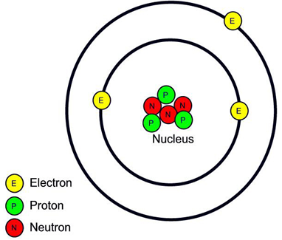

The protons and neutrons are located in the centre of the atom – called **the nucleus**.

The electrons revolve around the nucleus of the atom in fixed paths called orbits (shells) to form an electron cloud.

|  |  |  |  |
| --- | --- | --- | --- |
| **Particle** | **Location** | **Mass** | **Charge** |
| Proton | Inside the nucleus | 1 Unit | +1 |
| Neutron | Inside the nucleus | 1 Unit | 0 |
| Electron | Outside the nucleus | 2000 times smaller than the mass of a proton | -1 |

In general atoms are electrically neutral.

Therefore the number of protons must equal the number of electrons.

In some atoms the number of protons is also equal to the number of neutrons.

But not always - see *isotopes* below

**Atomic number**

**The number of protons in an atom is called *the Atomic number***

**Mass number**

**The number of protons *plus* neutrons in an atom is called *the Mass number***

**This means that the number of neutrons = Mass number – Atomic number**

**Example**

The atomic number of fluorine is 9 and its mass number is 19.

How many (i) protons, (ii) electrons and (iii) neutrons does a neutral fluorine atom have?

(i) 9 protons, (ii) 9 electrons (same number as the number of protons), (iii) 10 neutrons (19 – 9)

**Isotopes**

Scientists used to think that all atoms *of a given element* were identical, but then they discovered some elements have two or even three different types of atom.

They will all have the same number of protons (e.g. all sodium atoms have 11 protons, all atoms of carbon have 6 protons), but they could have a different number of neutrons.

e.g. some atoms of carbon have 6 neutrons, while other atoms of carbon have 8 neutrons.

We say these atoms are isotopes of each other.

So carbon-12 has 6 protons and 6 neutrons, but carbon-14 has 6 protons and 8 neutrons.

We say that carbon-12 and carbon-14 are isotopes.

**Isotopes are atoms which have the same atomic number but different mass number**

***One teaspoon of water contains about three times as many atoms as the Atlantic Ocean contains teaspoons of water.***

**Remember**

* If an atom has just one proton in it then that atom *must be* hydrogen.

If an atom has two protons in it then that atom is called helium etc.

* The number or protons that an atom contains is called its atomic number – it’s like the atom’s identity card.
* Many atoms are ‘neutral’; this means that they contain the same number of positive charges (protons) as negative charges (electrons).

These are the first 10 elements arranged in order of increasing atomic number:

|  |  |  |  |  |  |  |  |  |  |  |
| --- | --- | --- | --- | --- | --- | --- | --- | --- | --- | --- |
| **Atomic number** | 1 | 2 | 3 | 4 | 5 | 6 | 7 | 8 | 9 | 10 |
| **Element** | Hydrogen | Helium | Lithium | Beryllium | Boron | Carbon | Nitrogen | Oxygen | Fluorine | Neon |
| **Symbol** | H | He | Li | Be | B | C | N | O | F | Ne |

**Drawing the atoms: A Bohr diagram**

This way of understanding the atom was proposed by the Danish scientist Neils Bohr (pronounced “bore”) over 100 years ago, and so these diagrams are known as Bohr diagrams.

While all the protons and neutrons are packed tightly together in the central nucleus, the electrons are arranged in a very specific pattern, according to a set of rules.

1. **The electrons can orbit (go around) the nucleus as if they are on rings or shells around the nucleus**
2. **Only two electrons can be in the first orbital (shell).**
3. **Up to 8 electrons can be in all the other shells.**
4. **The inner shells must get filled up before electrons appear in an outer shell.**

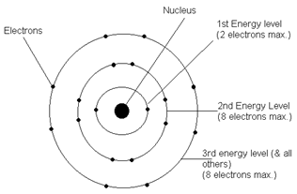

**Example: Argon**

Argon has an atomic number of 18.

This means that it has 18 protons and also 18 electrons.

So 2 electrons go in the first shell (represented by black dots).

8 electrons go in the next shell.

8 electrons go in the outside shell.

We call the arrangement of electrons **the electronic configuration.**

e.g. the electronic configuration of argon is 2,8,8

Calcium has an atomic number of 20, so the electronic configuration of calcium is 2,8,8,2

**The next 10 elements:**

|  |  |  |  |  |  |  |  |  |  |  |
| --- | --- | --- | --- | --- | --- | --- | --- | --- | --- | --- |
| **Atomic number** | 11 | 12 | 13 | 14 | 15 | 16 | 17 | 18 | 19 | 20 |
| **Element** | Sodium | Magnesium | Aluminium | Silicon | Phosphorus | Sulphur | Chlorine | Argon | Potassium | Calcium |
| **Symbol** | Na | Mg | Al | Si | P | S | Cl | Ar | K | Ca |

1. **Can you draw the Bohr diagram for the first 20 elements?**
2. It turns out that there are over 100 different types of element and for years scientists were puzzling over a way to group different types of atoms together based on some features that they might have in common. Can you think of way of grouping some of the different elements together based on the diagrams you have drawn?

**(for the answer to this mystery see the chapter entitled *The Periodic Table*).**

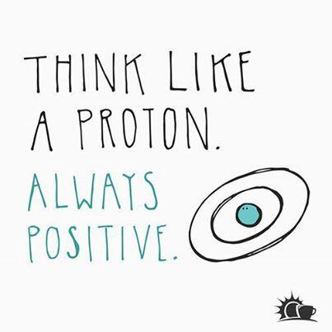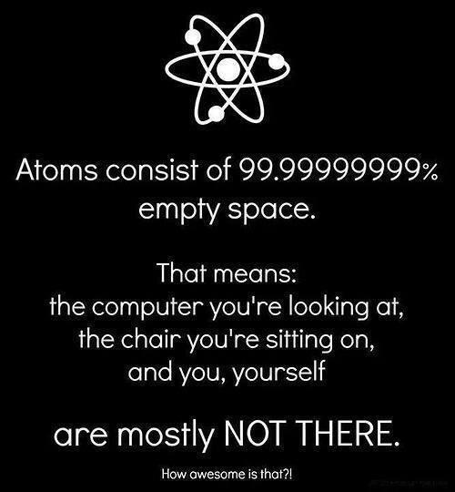

**Exam Questions**

1. [2006 OL]

Complete the statements below.

1. Protons are ________________ charged particles.
2. Electrons are ________________ charged particles.
3. [2007 OL]

Complete the sentences below..

1. Neutrons and ____ are located in the nucleus of atoms.
2. The ____move around outside the nucleus of atoms.
3. The ____have no electric charge.
4. [2008 OL]

Complete each statement below.

* 1. The ___________________ is a particle that has no electric charge.
  2. The ___________________ is a particle that has a positive charge.
  3. The ___________________ is a particle located outside the nucleus.
  4. The ___________________ is a particle that has a relative atomic mass of one unit.

1. [2011 OL][2010 OL]

Complete the table below by choosing the correct particle from the list on the right and matching it with the information in the table.

|  |  |  |  |
| --- | --- | --- | --- |
| **Particle** | **Location** | **Relative charge** | **Relative Mass** |
| A: | Inside nucleus | +1 | 1 |
| B: | Outside nucleus | –1 | 1/1850 |

|  |
| --- |
| Proton |
| Electron |
| Neutron |

1. [2009 OL]

Complete each statement below.

1. The particles located outside the nucleus are the ________________.
2. The particles that have no electric charge are the ________________.
3. The particles that have a positive charge are the _________________.
4. [2008]

Compare the charge and the mass of an electron with the charge and the mass of a proton, i.e. how does the charge of the electron compare to the charge of the proton and how does the mass of the electron compare to the mass of the proton?

1. [2007]

The diagram represents a sodium atom.

The circles are electron orbits and the ‘Na’ represents the nucleus. The atomic number of sodium is 11.

Using dots or Xs to represent electrons in the orbits give the electronic structure of sodium.

1. [2010]

A potassium atom has atomic number 19 and a mass number of 39.

Complete the diagram using dots or crosses to clearly show the arrangement of electrons in the potassium atom.

1. [2006]

Potassium has an atomic number of 19.

Give the arrangement of the electrons in an atom of potassium.

1. [2009]

Approximately 98.89% of carbon on the surface of the earth and in the atmosphere is carbon-12. The remaining approximately 1.11% is carbon-13. The numbers 12 and 13 are mass numbers. The atomic number of carbon is 6.

1. How many neutrons are in the nucleus of a carbon-13 atom?
2. Enter the missing word in the following sentence.

Carbon-12 and carbon-13 are _________________________ of carbon.

1. [2008]

Define atomic number.

1. [2011][2006][2008]Define the term ‘isotope’.

**WTF!**

We know from the *Static Electricity* chapter that similar charges repel, so why are there lots of protons hangin’ around together in the nucleus?  
Who’s telling us porkie pies??

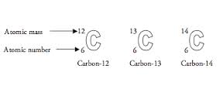

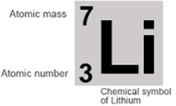**Exam Solutions**

1. 1. Positively
   2. Negatively
2. 1 – protons, 2 – electrons, 3 - neutrons
3. Neutron
4. Proton
5. Electron
6. Proton / neutron
7. A: Proton, B: Electron
8. Electrons
9. Neutrons
10. Protons
11. Electrons
12. Charge: electron is negative, proton is positive

Mass: electron is one 2000th of the mass of a proton

1. Two dots in inner circle, eight dots in ‘middle’ circle and one dot in the outer circle.
2. See diagram
3. 2,8 8,1
4. Seven
5. Isotopes
6. Atomic number is the number of protons in an atom
7. Isotopes are atoms which have the same atomic number (same number of protons) but a different mass number (different number of neutrons).

**Other Test Questions**

1. Describe the structure of the atom.
2. Give the location, relative charge, and atomic mass of the sub-atomic particles by filling in the following table:

|  |  |  |  |
| --- | --- | --- | --- |
| **Name of particle** | **Position in the atom** | **Relative charge** | **Atomic mass** |
| Proton | Proton |  |  |
| Neutron |  |  | 1unit |
| Electron |  | -1 |  |

1. Why are atoms neutral in charge?
2. For each of the following elements give the atomic number, mass number and the number of electrons: Hydrogen, Carbon, Neon and Calcium (you may make use of log tables).
3. Draw the Bohr structure of the following elements: Hydrogen, Carbon, Neon, Calcium (you may make use of log tables).

12

C

6

13

C

6

1. What is the difference between atoms of these two carbon isotopes:
2. Define the term *mass number*.

9

F

19

1. How many protons and neutrons are in an atom of fluorine?
2. Calcium has an atomic number of 20. Give the arrangement of electrons in an atom of Calcium.

12

Mg

24

1. Draw the arrangement of electrons in an atom of the element Magnesium.